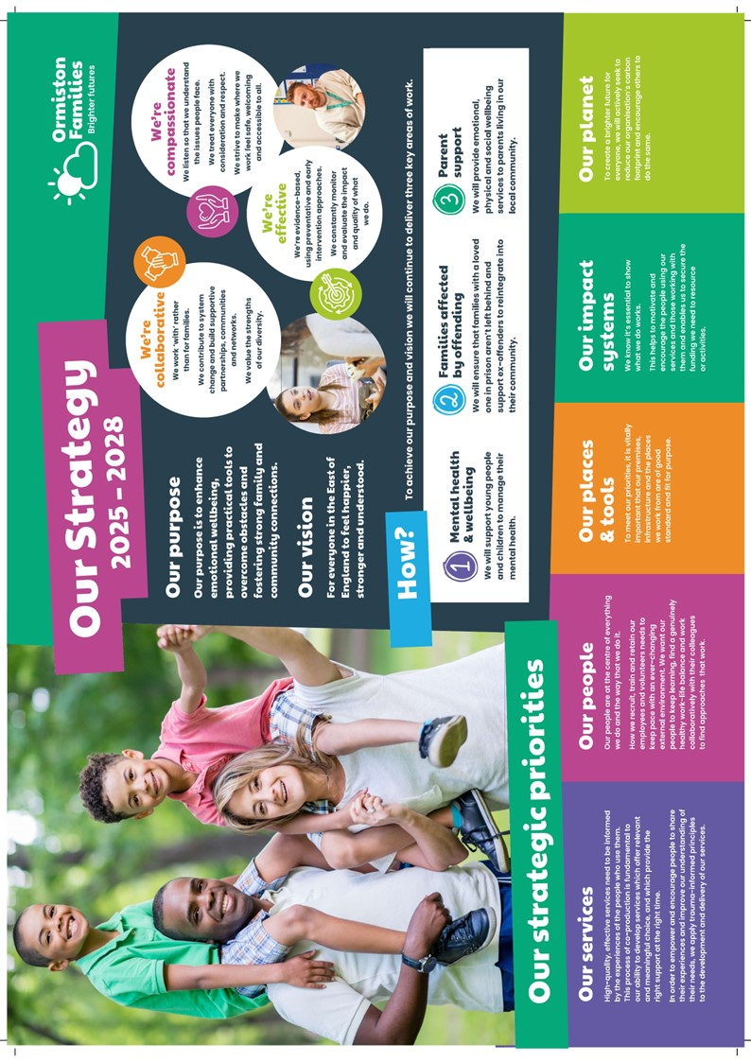
Deputy Team Manager
YOUnited

A message from our CEO, Bruce Leeke

Dear Applicant,

Thank you for your interest in the post of Deputy Team Manager in our YOUnited Service.

It’s an exciting time for our charity. After more than four decades of changing lives and strengthening communities in the East of England, we continue to deliver highly impactful services that reflect our values of compassion, collaboration, and effectiveness. What we do benefits thousands of children and families every year, and we are ambitious to build on our legacy.

We are constantly looking at new ways to improve the outcomes of our beneficiaries through co-production, innovation, and partnerships. Our people are at the heart of everything we do, acting as the conduit to brighter futures for the children and families we support. We hope that our approach inspires you to take the next step in your career with us.

Wishing you the best of luck with your application.

Best regards,


Bruce Leeke

Who Are Ormiston Families?

Ormiston Families is one of the leading charities working with children, young people, and families in the East of England. We take early and preventative action to support families to be safe, healthy, and resilient. All our services help people to build stronger networks, learn from experience and feel in control of their own wellbeing. We can only achieve this with the people who choose to work for us.

About Our YOUnited service

YOUnited is part of a partnership that has been established to transform and bring together mental and emotional health services for children and young people in Cambridgeshire and Peterborough. Centre 33 and Ormiston Families are joining their expertise in therapeutic support alongside Cambridgeshire and Peterborough Foundation Trust (CPFT). The partnership is committed to using the THRIVE framework of Getting Advice, Getting Help, Getting More Help and Risk Support.

About the role

The Deputy Team Manager will provide line management and support to the team managers, meeting the needs of our growing service.

The role is part of the YOUnited partnership, and alongside providing line management supervision, you will be expected to represent Ormiston Families at the partnership’s multi-disciplinary meetings and deputise for the team managers as and when required.

You will play an active part in the management of our duty system, offering advice, guidance and risk management support to families. This will be done using a ‘Single Session Thinking’ approach.

You will work alongside the service manager and team manager to ensure continued service improvements are made in line KPI’s and the YOUnited business plan.

About you

The post holder will have leadership experience and experience working with children and young people therapeutically aged 5-13, and their parents/carers. You will hold a clinical qualification, including RMN/RN Child, Social Worker, Counsellor, Children’s Wellbeing Practitioner, and Education Mental Health Practitioner.

Safer Recruitment

Application Process / Post Requirement
You must demonstrate that you meet the competencies, experience, knowledge, skills, and qualifications that are required for this role (see Job Description below).
You must complete and submit an online application form (via the ‘Work with Us’ section of our website) detailing in the personal statement section how you meet the criteria.

Rights to Work in the UK (RTW) (in person or remote)
The Recruiting Manager will need to see the original documents providing proof of your right to work in the UK.
- UK Passport / Full UK Birth Certificate / Driver's Licence / Utilities Bill
(proof of address)
- EUSS Permanent Status or Pre-Status Share Code
- Current EU/EAA/Swiss Citizen Passport
- EU/EAA/Swiss Citizen Visa
- Home Office Certificate
- If the interview is held in person, we will verify hard-copy documents, which you will need to bring with you to the interview.
- If the interview is held remotely, you will need to email copies of your RTW documents to the Recruiting Manager before the interview. At the remote interview [Teams, Zoom], you will need to have the original hard-copy documents available so the relevant checks can be undertaken.

Safeguarding and DBS Requirements for Your Role
Ormiston Families is committed to safeguarding and promoting the welfare of children, young people and adults at risk and expects all staff and volunteers to share this commitment. DBS checks or police vetting will be required for relevant posts.

Disclosure and Barring Service (DBS) Checks:
- As this position meets the definition of regulated activity under the Protection of Freedoms Act 2012, appointments to this post will be subject to an enhanced DBS check with a barred list check.
- Employment can commence once the check has been satisfactorily completed.
- If you have a conviction on your DBS check, an assessment of the relevance and impact of the conviction in relation to the post will be done to determine if the job offer can be confirmed.
- It is a serious criminal offence to knowingly apply for posts when you have been barred from working with children/young people and/or vulnerable adults.
- Additional questions for roles working with children, young people, or vulnerable adults to be explored at interview.
- As this post involves working either with children and young people or vulnerable adults, Warner or Safer Care motivational-type questions may be asked during the interview process.
- These questions are asked to establish your suitability to work with vulnerable groups by understanding your attitude, behaviour, and responses to situations.
- The questions will relate to your inspiration for working with vulnerable groups, your ability to build relationships and your resilience when working with such groups and may also explore your attitude to the use of authority.
- If you feel you would find these questions about yourself difficult to respond to, then you may wish to reflect upon your suitability for the post.

Disclosure
- Ormiston Families encourages all candidates called for interview to provide details of their criminal record at an early stage in the application process.
  - This information can be sent under separate, confidential cover to the Human Resources Team at hr@ormistonfamilies.org.uk
  - Ormiston Families guarantees that this information will only be seen by those who need to see it as part of the recruitment process.
- Unless the nature of the position allows Ormiston Families to ask questions about your entire criminal record, only questions about "unspent" convictions as defined in the Rehabilitation of Offenders Act 1974 will be asked.
- Ormiston Families will ensure that every subject of a DBS Disclosure is aware of the existence of the DBS Code of Practice and that a copy is available on request.
- Ormiston Families undertakes to discuss any matter revealed in a Disclosure with the person seeking the position before withdrawing a conditional offer of employment.
- Having a criminal record will not necessarily bar you from working with Ormiston Families. This will depend on the nature of the position and the circumstances and background of the offences.

Qualification
- The Recruiting Manager will need to see the original copies of your qualifications either in person or via video conference.
- If the interview is held in person, we will verify hard-copy documents, which you will need to bring with you to the interview.
- If the interview is held via video conference, you will need to email copies of your qualifications to the Recruiting Manager before the interview. At the interview, you will need to have the original hard copy documents available so the relevant checks can be undertaken.
- If you are shortlisted and are required to hold a particular qualification for a post, it is your responsibility to provide the relevant certification to prove you are suitably qualified.
- Failure to produce documentary evidence of qualifications or undertake required courses/training may result in the termination of your employment.
- If a post requires you to take training or additional qualifications, then, by accepting this post, you are agreeing to do the training or take the qualifications.

References
- If appointed, we will ask you for referee details which cover your past 3 years of employment, one of which must be your current/most recent employer.

Health Check
- If appointed, and to ensure the post does not have a detrimental effect on your health or your health on your work, you will have to complete a health enquiry form, and may be required to have a medical via Occupational Health.
- This is to confirm that you can satisfactorily carry out the post without any impact on your health (taking into account any reasonable adjustments required).
- It will be separated from your application form and will not be seen by anyone involved in recruitment for this job.

GDPR / Data Protection:
- Ormiston Families is required by law to comply with the UK GDPR / Data Protection Act 2018.
- Employees have an important role to play in ensuring that personal information is processed lawfully and fairly.
- Personal information is information relating to a living individual who can be identified.
- It is each employee’s responsibility to handle all personal information properly, no matter how it is collected, recorded, or used, whether on paper, in a computer, or on other material.
- Personal information must not be disclosed to others unless authorised to do so.
- All personal /sensitive information will be sent to you via Egress encryption service or password-protected.

Equal Opportunities:
- Ormiston Families is an equal opportunities employer.
- We value diversity and welcome applications from all sections of the community.
- We ask you to complete a monitoring form to help us monitor the diversity of applicants. It will be separated from your application form and will not be seen by anyone involved in recruitment for this job.
- The gender identity, disability, marital status, ethnic origin, age, pregnancy status, religion or belief, or sexual orientation of an applicant or employee does not affect the employment opportunities made available, except as permitted by legislation.
- In addition, applicants declaring a disability who meet the minimum (essential) criteria for a vacancy will be invited for an interview.
- Ormiston Families seeks to ensure that all employees are selected, trained, and promoted based on ability, the requirements of the post and other similar and objective criteria.

Any queries, please email: Gemma.Balnaves@ormistonfamilies.org.uk

Ormiston Families reserves the right to close the vacancy early if we have received sufficient applications ahead of the closing date.

Information about working
for Ormiston Families

Job Title: Deputy Team Manager

Duration
The post advertised is a full-time, 12-month temporary position.

Hours of Work and Working Arrangements:
- The normal working week is 35 hours, Monday to Friday 9:00 am – 5:00 pm, and covers 52 weeks per year.
- You will be required to work flexibly to meet the needs of the service, which may include evenings and weekends.

Location:
- You are home-based with the ability to travel across Peterborough and Cambridgeshire.

Salary:
- The salary for this post is £38,000 per annum, based on 35 hours per week.
- Salary is paid in 12 equal instalments on the 25th of each month directly into your bank account and covers work carried out in the calendar month.

Probationary Period:
- The post is subject to a probationary period of 3 months during which your progress will be monitored in accordance with agreed objectives.

Travelling Requirements for Your Role
- Ormiston Families positively encourages the use of technology to communicate and engage, but in this role, you will need to travel.
- You must either hold a full and current driving licence and have access to personal transport or meet the mobility requirements of the role through other reasonable and suitable means.
- Any mileage undertaken on behalf of Ormiston Families will be paid in accordance with our Expenses Policy and within Her Majesty’s Revenue and Customs guidelines.
- If you require a reasonable adjustment due to a disability to meet the travel requirements of this role, please speak with the contact details below.
- If you use your own vehicle for work, you must ensure that your insurance policy covers you for this purpose.



Job Description

Job Title: Deputy Team Manager
Service: YOUnited
Location: Home working with the ability to travel across Peterborough and Cambridgeshire

Job Purpose
The purpose of the role is to provide line management and day to day support to the team managers to meet the needs of our growing service and to be an active part of the YOUnited partnership.

Alongside providing line management supervision, you will be expected to represent Ormiston Families at the partnership’s Multidisciplinary meeting and deputise for the team managers as and when required.

You will play an active part in the management of our duty system, offering advice, guidance and risk management support to families. This will be done using a ‘Single Session Thinking’ approach.

You will work alongside the service manager and team manager to ensure continued service improvements are made in line KPI’s and the YOUnited business plan.

Main Duties and Responsibilities
- To provide line management supervision, including inductions and appraisals.
- Providing cover for the team managers as and when required.
- To work as part of a multidisciplinary team and build worthwhile relationships within the YOUnited partnership.
- To use your clinical background to guide your decision-making process in relation to children and young people with mild to moderate mental health or emotional wellbeing problems.
- To provide advice, guidance and support to parents, caregivers or professionals using a ‘single session’ approach.
- To assess clinical risk and safety, escalating cases appropriately and supporting practitioners with these tasks.
- To provide advice and guidance to practitioners, which may include clinical or procedural queries and safeguarding.
- Lead on designated service development projects, working closely with the service manager and team manager.
- Participate in audits of practitioners’ clinical work and offer feedback where required.
- To support allocations, working alongside senior colleagues.

General
- To support a team culture of warmth, respect, best practice, good communication and shared risk management, in line with Ormiston Families values.
- To support a culture of continuous learning and development, identifying training needs and supporting and delivering internal training.
- To comply with all legislation, policies, procedures, protocols and guidelines.
- Undertaking other tasks based on the business needs as and when required.
- Engage with own supervision in accordance with relevant professional/ethical frameworks.
- To demonstrate an active commitment to safeguarding CYP and vulnerable adults.
- To demonstrate willingness and eagerness to embed change and take on new trainings and challenges.
- Operate, always, from an inclusive values base, which recognises and respects diversity.

Personal Specification

Qualifications
Essential | Desirable
Clinical qualification
(RMN/RN Child, Social Worker, Counsellor, Children’s Wellbeing Practitioner, Education Mental Health Practitioner).
Supervision qualification or evidence of relevant training and experience.

Experience
Essential | Desirable
Leadership experience in a relevant field. | Leadership experience within a children’s mental health setting.
Experience of working with children and young people therapeutically aged 5-13 | Knowledge of working with key performance indicators and interpreting data.
Working collaboratively with service users and their families/carers. | Experience of working collaboratively with children, young people and families to drive and plan service delivery.
Experience of liaising with and providing guidance to professionals.
Experience of using safeguarding processes to protect the needs of CYP.
Experience of partnership working and communicating with a wide range of stakeholders.
Experience of leading on projects & Service development.
Completing robust clinical assessments with CYP and their families/carers, including risk assessment and safety planning.
Experience and confidence to manage performance concerns.

Abilities and Knowledge
Essential | Desirable
Use and knowledge of single-session thinking, or willingness to train. | An understanding of a broad range of therapeutic interventions.
Knowledge of child development.
Knowledge of statutory services (including CAMHS and Children’s Social Care), their function and appropriate referral procedures.
Knowledge and understanding of mental health presentations in children, young people and adults.
Knowledge of, and ability to operate within, professional and ethical guidelines
Knowledge of, and ability to work with, issues of confidentiality, consent and capacity.
Ability to engage and communicate with families, parents and carers of different backgrounds and developmental levels. (Cultural competence)
Knowledge of the use of Routine Outcome Measures at the practitioner and service level.
Knowledge, awareness and experience of low-intensity interventions.
A good level of IT competency and a willingness to learn new systems and engage with them, e.g. electronic record keeping.

Professional and Personal Development
- All staff must ensure that they are aware of their responsibilities by attending mandatory training and our induction programme.
- All staff will have a formal appraisal with their manager at least every 12 months. Once performance/training objectives have been set, the staff member’s progress will be reviewed regularly so that new objectives can be agreed and set to maintain progress in service delivery.
- All staff will be expected to take responsibility for their own professional development and will be supported to achieve development opportunities as appropriate.

Health and Safety
- All staff have a responsibility to maintain the health and safety of themselves and others within the performance of duties in accordance with health and safety policies, and to undertake specific health and safety responsibilities as directed. All staff have a responsibility to adhere to the risk management policies & procedures.
- All staff are required to contribute to the control of risk and must report immediately any incident, accident or near miss involving service users, carers, staff, contractors, or members of the public.

Confidentiality and Information Governance
- All staff may gain or have access to confidential information about the assessment and/or treatment of service users, information affecting the public, private or work-related staff information, or charity matters. A breach of confidentiality will have occurred where any such information has been divulged, passed (deliberately or accidentally) or overheard by any unauthorised person or persons. Breaches of confidentiality can result in disciplinary action, which may involve dismissal.
- All staff must maintain a high standard of quality in corporate and clinical record-keeping, ensuring information is always recorded accurately, appropriately and kept up to date. Staff must only access information, whether paper, electronic or in other media, which is authorised to them as part of their duties.
- All staff must ensure compliance with the Data Protection Act 2018 and the UK GDPR.

Safeguarding: Adults and Children (Section 11 of the Children Act 2004)
- Every member of staff has a responsibility to be aware of and follow at all times the relevant national and local policy in relation to safeguarding children and safeguarding adults.
- Safeguarding and DBS requirements for your role:
- Ormiston Families is committed to safeguarding and promoting the welfare of children, young people and adults at risk and expects all staff and volunteers to share this commitment. DBS checks or police vetting will be required for relevant posts.

Senior Managers
- Under Section 11 of the Children Act, senior managers have responsibility for ensuring that service developments take into account the promotion of welfare and are informed by the views of children and families; providing training on safeguarding for all staff; recruiting safely; ensuring there is effective inter-agency working and information sharing.


Freedom of Information (FOI)
- All members of staff must be aware of their responsibilities under the Freedom of Information (FOI) Act 2000. The Act gives individuals or organisations the right to request information held by the charity. Staff must manage information they hold in such a way that meets the requirements of the Act. All requests for disclosures under the Act must be passed to the Privacy Officer.

Data Quality
- The Charity recognises the role of reliable information in the delivery & development of its services and in assuring robust clinical and corporate governance. Data quality is central to this, and the availability of complete, comprehensive, accurate and timely data is an essential component in the provision of high-quality mental health services. It is therefore the responsibility of all staff to ensure that, where appropriate, information is recorded at all times, in line with the charity’s policy and procedures for data quality.
- This job description seeks to provide an outline of the duties and responsibilities of the post. It is not a definitive document and does not form part of the main statement of terms and conditions. The job description will be reviewed as part of the annual appraisal process and will be used as the basis for setting objectives.

Benefits & Recognition
All benefits are discretionary, and Ormiston Families reserves the right to change or amend benefits at any given time.
Cycle to Work
- Cycle to Work allows you to order a new bike, equipment or both up to the value of £1,000, which you can pay back through your salary to make tax savings.

Annual Leave Entitlement:
- The basic annual leave entitlement is 27 days plus additional leave for employees who have completed 1 years’ service up to a maximum of 30 days
- Part-time employees receive a pro-rata allowance according to the number of hours they work per week.
- Ability to buy and sell up to 5 days’ annual leave within any leave year. (All leave must be taken within the year it is purchased, including any agreed leave brought forward from the previous year.)

Group Life Assurance:
- Ormiston Families provides a death in service benefit up to the age of 70, which includes and covers permanent, fixed-term and as & when contracted employees.
Occupational Sick Pay Scheme:
- Ormiston Families operates an occupational sick pay scheme in addition to statutory sick pay.

Pension:
- Ormiston Families provides a Group Personal Pension Scheme with up to 9% of gross salary employer contribution for any employee where they match the level of contribution.

Sponsorship:
- Ormiston Families provides the opportunity to apply for sponsorship to employees who have completed their probationary period and have been in post for at least 12 months to undertake nationally accredited or chartered certification awarded by professional associations.
Employee Assistance Programme:
- Ormiston Families provides a comprehensive employee assistance programme which offers free and confidential access to telephone and unlimited video counselling sessions, financial and legal advice, and assistance in finding information about a wide range of subjects from childcare to moving to a new house.

Employee Discount Scheme:
- The Hive is a savings platform which can be accessed by employees to make everyday purchases at reduced costs. Employees can save money by purchasing reloadable cards, obtain cashback through online purchases, and make savings in many stores.

Your Wellbeing:
- We have trained Mental Health First Aiders who form our Wellbeing Team, promoting mental and physical health. Ormiston Families has also signed the pledge to support our employees going through the menopause in the workplace.

The Wellbeing Centre:
- Accessed via The Hive, the Wellbeing Centre provides education, support and tools to help you live a healthier and happier life.

Pets in the Workplace:
- We are a dog-friendly employer, which means that from time to time we allow colleagues to bring their pets into our workplaces. If you would like a copy of our Pets in the Workplace policy or would like to discuss this in more detail, please contact our HR team.


We build supportive partnerships, communities, and networks

