Play Therapist
Supporting Smiles

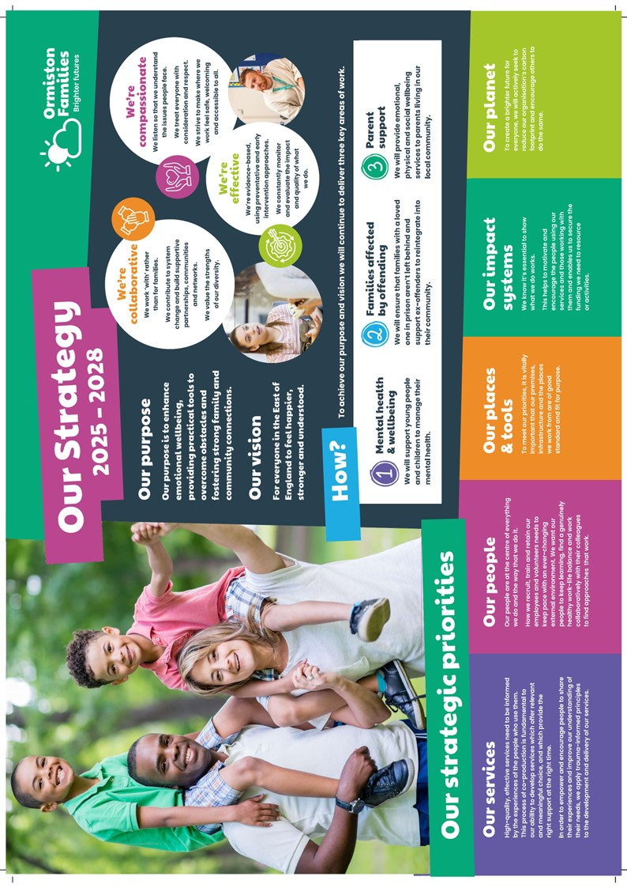
A message from our CEO, Bruce Leeke

Dear Applicant,

Thank you for your interest in the post of Play Therapist in our Supporting Smiles service.

It’s an exciting time for our charity. After more than four decades of changing lives and strengthening communities in the East of England, we continue to deliver highly impactful services that reflect our values of compassion, collaboration, and effectiveness. What we do benefits thousands of children and families every year, and we are ambitious to build on our legacy.

We are constantly looking at new ways to improve the outcomes of our beneficiaries through co-production, innovation, and partnerships. Our people are at the heart of everything we do, acting as the conduit to brighter futures for the children and families we support. We hope that our approach inspires you to take the next step in your career with us.

Wishing you the best of luck with your application.

Best regards,


Bruce Leeke

Who Are Ormiston Families?

Ormiston Families is one of the leading charities working with children, young people, and families in the East of England. We take early and preventative action to support families to be safe, healthy, and resilient. All our services help people to build stronger networks, learn from experience and feel in control of their own wellbeing. We can only achieve this with the people who choose to work for us.

About Our Supporting Smiles service

Ormiston Families has held the contract to deliver mental health services to young people and families for over a decade. We offer high-quality 1:1 therapy and early intervention programmes to children and young people between the ages of 4 and 18 who experience social, emotional, and behavioural challenges. We also offer parent-led interventions and family-based support. We work collaboratively across an innovative alliance of partner providers in the processing and coordination of referrals for those aged 0–25

About the role

We are looking for a passionate and creative Play Therapist to join our Supporting Smiles Children and Young People's Mental Health Service. Working with children aged 4–13 years, you will provide specialist play therapy interventions to support those experiencing emotional, behavioural, and mental health difficulties.

You will undertake therapeutic assessments, develop formulations, and deliver evidence-informed interventions tailored to the individual needs of children and their families. Working closely with parents, carers, schools, and wider professionals, you will help children better understand and manage their emotions, build resilience, and achieve positive outcomes.

As part of a multidisciplinary team, you will collaborate with a range of therapeutic practitioners to ensure children receive the right support at the right time. You will also contribute to service development initiatives aimed at improving access to support, reducing waiting times, and enhancing the experience of children and families accessing mental health services.

We offer a supportive, reflective, and values-led working environment where innovation and professional growth are encouraged. You will receive regular clinical supervision, reflective practice opportunities, and ongoing continuing professional development to support your therapeutic practice and career progression.

Most importantly, this is an opportunity to make a genuine difference in the lives of children, young people, and families by delivering meaningful therapeutic support when it matters most.

About you
You will be a qualified Play Therapist with professional registration through PTUK, BAPT, APT, or an equivalent recognised professional body. You will have experience of working therapeutically with children and young people, undertaking assessments, developing formulations, and delivering creative, evidence-informed interventions that support emotional wellbeing and positive mental health outcomes.

You will be a compassionate and reflective practitioner who can build trusting relationships with children, young people, families, schools, and professional partners. You will be confident working both independently and as part of a multidisciplinary team, contributing your specialist expertise while collaborating with colleagues to achieve the best possible outcomes for children and young people.

Most importantly, you will share our commitment to delivering high-quality, child-centred care and be passionate about helping children and young people develop resilience, overcome challenges, and thrive.

Join us and play a vital role in improving the emotional well-being and mental health of children and young people across Norfolk and Waveney.

Safer Recruitment

Application Process / Post Requirement
You must demonstrate that you meet the competencies, experience, knowledge, skills, and qualifications, that are required for this role (see Job Description below).
You must complete and submit an online application form (via the ‘Work with Us’ section of our website) detailing in the personal statement section how you meet the criteria.

Rights to Work in the UK (RTW) (in person or remote)
The Recruiting Manager will need to see the original documents providing proof of your right to work in the UK.
- UK Passport / Full UK Birth Certificate / Drivers Licence / Utilities Bill
(proof of address)
- EUSS Permanent Status or Pre-Status Share Code
- Current EU/EAA/Swiss Citizen Passport
- EU/EAA/Swiss Citizen Visa
- Home Office Certificate
- If the interview is held in person, we will verify hard copy documents, which you will need to bring with you to the interview.
- If the interview is held remotely, you will need to email copies of your RTW documents to the Recruiting Manager before the interview. At the remote interview [Teams, Zoom], you will need to have the original hard copy documents available so the relevant checks can be undertaken.

Safeguarding and DBS Requirements for Your Role
Ormiston Families is committed to safeguarding and promoting the welfare of children, young people and adults at risk and expects all staff and volunteers to share this commitment. DBS checks or police vetting will be required for relevant posts.

Disclosure and Barring Service (DBS) Checks:
As this position meets the definition of regulated activity under the Protection of Freedom Act 2012, appointments to this post will be subject to an enhanced DBS check with barred list check.
- Employment can commence once the check has been satisfactorily completed.
- If you have a conviction on your DBS check, an assessment of the relevance and impact of the conviction in relation to the post will be done to determine if the job offer can be confirmed.
- It is a serious criminal offence to knowingly apply for posts when you have been barred from working with children/young people and/or vulnerable adults.
- Additional questions for roles working with children, young people, or vulnerable adults to be explored at interview.
- As this post involves working either with children and young people or vulnerable adults, Warner or Safer Care motivational type questions may be asked during the interview process.
- These questions are asked to establish your suitability to work with vulnerable groups by understanding your attitude, behaviour, and responses to situations.
- The questions will relate to your inspiration for working with vulnerable groups, your ability to build relationships and your resilience when working with such groups and may also explore your attitude to the use of authority.
- If you feel you would find these questions about yourself difficult to respond to, then you may wish to reflect upon your suitability for the post.

Disclosure
- Ormiston Families encourages all candidates called for an interview to provide details of their criminal record at an early stage in the application process.
  - This information can be sent under separate, confidential cover to the Human Resources Team, hr@ormistonfamilies.org.uk
  - Ormiston Families guarantees that this information will only be seen by those who need to see it as part of the recruitment process.
- Unless the nature of the position allows Ormiston Families to ask questions about your entire criminal record, only questions about "unspent" convictions as defined in the Rehabilitation of Offenders Act 1974 will be asked.
- Ormiston Families will ensure that every subject of a DBS Disclosure is aware of the existence of the DBS Code of Practice and make a copy available on request.
- Ormiston Families undertakes to discuss any matter revealed in a Disclosure with the person seeking the position before withdrawing a conditional offer of employment.
- Having a criminal record will not necessarily bar you from working with Ormiston Families. This will depend on the nature of the position, the circumstances and background of the offences.

Qualification
- The Recruiting Manager will need to see the original copies of your qualification either in person or via video conference.
- If the interview is held in person, we will verify hard copy documents, which you will need to bring with you to the interview.
- If the interview is held via video conference, you will need to email copies of your qualifications to the Recruiting Manager before the interview. At the interview, you will need to have the original hard copy documents available so the relevant checks can be undertaken.
- If short-listed and you are required to hold a particular qualification for a post, it is your responsibility to provide the relevant certification to prove you are suitably qualified.
- Failure to produce documentary evidence of qualifications or undertake required courses/training may result in the termination of your employment.
- If a post requires you to take training or additional qualifications, then by accepting this post, you are agreeing to do the training or take the qualifications.

References
- If appointed, we will ask you for referee details which cover your past 3 years of employment, one of which must be your current/most recent employer.

Health Check
- If appointed, and to ensure the post does not have a detrimental effect on your health or your health on your work, you will have to complete a health enquiry form, and may be required to have a medical via Occupational Health.
- This is to confirm that you can satisfactorily carry out the post without any impact on your health (taking account of any reasonable adjustments required).
- It will be separated from your application form and will not be seen by anyone involved in recruitment to this job.

GDPR / Data Protection:
- Ormiston Families is required by law to comply with the UK GDPR / Data Protection Act 2018.
- Employees have an important role to play in ensuring that personal information is processed lawfully and fairly.
- Personal information is information relating to a living individual who can be identified.
- It is each employee’s responsibility to handle all personal information properly, no matter how it is collected, recorded, and used, whether on paper, in a computer, or on other material.
- Personal information must not be disclosed to others unless authorised to do so.
- All personal /sensitive information will be sent to you via the Egress encryption service or password-protected.

Equal Opportunities:
- Ormiston Families is an equal opportunities employer.
- We value diversity and welcome applications from all sections of the community.
- We ask you to complete a monitoring form to help us monitor the diversity of applicants. It will be separated from your application form and will not be seen by anyone involved in recruitment to this job.
- The gender identity, disability, marital status, ethnic origin, age, pregnancy status, religion or belief, or sexual orientation of an applicant or employee does not affect the employment opportunities made available, except as permitted by legislation.
- In addition, applicants declaring a disability who meet the minimum (essential) criteria for a vacancy will be invited for an interview.
- Ormiston Families seeks to ensure that all employees are selected, trained, and promoted based on ability, the requirements of the post and other similar and objective criteria.

Any queries, please email: cassie.ruffell@ormistonfamilies.org.uk

Ormiston Families reserves the right to close the vacancy early if we have received sufficient applications ahead of the closing date.

Information about working
for Ormiston Families

Job Title: Play Therapist

Duration
The post advertised is a fixed-term, full-time position.

Hours of Work and Working Arrangements:
- The normal working week is 37.5 hours, Monday to Friday and covers 52 weeks per year.
- You will be required to work flexibly to meet the needs of the service, which may include evenings and weekends.

Location:
- Your base will be our Norwich Hub with a blend of remote working and working within the community across Norfolk & Waveney.

Salary:
- The salary for this post is £34,467.72 per annum, based on 37.5 hours per week.
- Salary is paid in 12 equal instalments on the 25th of each month directly into your bank account and covers work carried out in the calendar month.

Probationary Period:
- The post is subject to a probationary period of 3 months during which your progress will be monitored in accordance with agreed objectives.

Travelling Requirements for Your Role
- Ormiston Families positively encourages the use of technology to communicate and engage, but in this role, you will need to travel.
- You must either hold a full and current driving licence and have access to personal transport or meet the mobility requirements of the role through other reasonable and suitable means.
- Any mileage undertaken on behalf of Ormiston Families will be paid in accordance with our Expenses Policy and within Her Majesty’s Revenue and Customs guidelines.
- If you require a reasonable adjustment due to a disability to meet the travel requirements of this role, please speak with the contact detailed below.
- If you use your own vehicle for work, you must ensure that your insurance policy covers you for this purpose.



Job Description

Job Title: Play Therapist
Service: Supporting Smiles
Location: Based in our Norwich Hub with a blend of remote working and working within the community across Norfolk & Waveney.

Job Purpose
The successful candidate will provide evidence-based play therapy interventions to children one-to-one and in groups experiencing emotional, behavioural and mental health difficulties. They will work collaboratively with families, schools and partner agencies to improve outcomes and support children to build resilience, emotional wellbeing and positive coping strategies.

Main Duties and Responsibilities
Clinical Practice
- Undertake assessments, formulation and intervention planning for children referred into the service.
- Deliver high-quality, evidence-based play therapy interventions appropriate to the child's presenting needs.
- Develop child-centred therapeutic plans informed by assessment, formulation and outcome measures.
- Maintain a safe therapeutic environment that promotes emotional expression, exploration and growth.
- Adapt interventions to meet the developmental, emotional and cultural needs of individual children.
- Work collaboratively with parents, carers and professionals to support therapeutic goals and positive outcomes.
- Undertake risk assessments and safety planning where required.
- Identify safeguarding concerns and escalate appropriately in line with organisational policies.

Service Delivery
- Manage a caseload of children and families in line with service expectations.
- Deliver interventions across community venues, schools, family hubs and Ormiston Families locations.
- Support smooth transitions between pathways and services where required.
- Contribute to reducing waiting times through effective caseload management and timely intervention delivery.
- Promote engagement and reduce non-attendance through proactive communication with families.
Outcome Monitoring and Quality
- Complete routine outcome measures and experience measures in line with service requirements.
- Maintain accurate and contemporaneous clinical records using organisational systems.
- Provide reports, summaries and professional opinions where appropriate.
- Contribute to service evaluation, quality improvement and audit activity.
- Participate in clinical supervision, reflective practice and peer support.
Partnership Working
- Build positive relationships with schools, social care, health partners and wider community organisations.
- Represent Supporting Smiles professionally within multi-agency meetings where required.
- Promote awareness of Supporting Smiles and wider Ormiston Families services.

Professional Responsibilities
- Maintain professional registration/accreditation.
- Participate in continuing professional development.
- Work within professional codes of ethics and practice standards.
- Contribute to the ongoing development of therapeutic services within Supporting Smiles.

Generic Responsibilities
- Comply with all Ormiston Families policies and procedures.
- Demonstrate commitment to safeguarding, equality, diversity and inclusion.
- Undertake any other duties commensurate with the role.

Generic Duties
- To undertake any other reasonable duty, which is appropriate to the grade, when requested by senior staff.
- To be familiar with and comply with all Ormiston Families policies, procedures, protocols, and guidelines.
- To demonstrate an understanding and commitment to the charity’s values.
- You may be required to conduct other tasks based on the business needs.

Personal Specification

Qualifications
Essential | Desirable
Recognised qualification and a minimum of a diploma in Play Therapy. | Post-qualification specialist training in trauma, attachment, neurodiversity or child mental health.
Accredited or registered with PTUK, BAPT, APT or equivalent professional body. | Clinical supervision qualification.
Evidence of continuing professional development. | Additional therapeutic qualification.
Eligibility to work with children and young people within a therapeutic setting.

Experience
Essential | Desirable
Experience delivering therapeutic interventions to children and young people. | Experience within CYP mental health services.
Experience in assessment, formulation and treatment planning. | Experience within education settings.
Experience of working with emotional well-being and mental health presentations. | Experience working within a multidisciplinary team.
Experience in maintaining professional clinical records and outcome measures. | Experience supporting neurodiverse children and young people.
Experience working collaboratively with parents, carers and professionals. | Experience delivering group-based interventions or parent support.

Abilities and Knowledge
Essential | Desirable
Sound understanding of child development. | Knowledge of THRIVE principles.
Knowledge of attachment, trauma and emotional well-being. | Knowledge of CYP-IAPT principles.
Understanding of safeguarding legislation and procedures. | Understanding of local CYP mental health pathways.
Ability to undertake risk assessment and safety planning. | Experience using routine outcome measures.
Strong communication and relationship-building skills.
Ability to work independently and manage a caseload.
Ability to maintain accurate clinical records.
IT literacy and confidence using electronic case management systems.

Other requirements
Essential | Desirable
Ability to travel across Norfolk and Waveney.
Flexible approach to service delivery.
Full UK driving licence and access to own vehicle.

Professional and Personal Development
- All staff must ensure that they are aware of their responsibilities by attending mandatory training and our induction programme.
- All staff will have a formal appraisal with their manager at least every 12 months. Once performance/training objectives have been set, the staff member’s progress will be reviewed on a regular basis so that new objectives can be agreed and set, to maintain progress in the service delivery.
- All staff will be expected to take responsibility for their own professional development and will be supported to achieve development opportunities as appropriate.

Health and Safety
- All staff have a responsibility to maintain the health and safety of themselves and others within the performance of duties in accordance with health and safety policies, and to undertake specific health and safety responsibilities as directed. All staff have a responsibility to adhere to the risk management policies & procedures.
- All staff are required to contribute to the control of risk, and must report immediately any incident, accident or near miss involving service users, carers, staff, contractors, or members of the public.

Confidentiality and Information Governance
- All staff may gain or have access to confidential information about the assessment and/or treatment of service users, information affecting the public, private or work-related staff information, or charity matters. A breach of confidentiality will have occurred where any such information has been divulged, passed (deliberately or accidentally) or overheard by any unauthorised person or person(s). Breaches of confidentiality can result in disciplinary action, which may involve dismissal.
- All staff must maintain a high standard of quality in corporate and clinical record keeping, ensuring information is always recorded accurately, appropriately and kept up to date. Staff must only access information, whether paper, electronic or in other media, which is authorised to them as part of their duties.
- All staff must ensure compliance with the Data Protection Act 2018 and the UK GDPR.

Safeguarding: Adults and Children (Section 11 of the Children Act 2004)
- Every member of staff has a responsibility to be aware of and follow at all times the relevant national and local policy in relation to safeguarding children and safeguarding adults.
- Safeguarding and DBS requirements for your role:
- Ormiston Families is committed to safeguarding and promoting the welfare of children, young people and adults at risk and expects all staff and volunteers to share this commitment. DBS checks or police vetting will be required for relevant posts.

Senior Managers
- Under Section 11 of the Children Act, senior managers have responsibility for ensuring that service developments take into account the promotion of welfare and are informed by the views of children and families; providing training on safeguarding for all staff; recruiting safely; ensuring there is effective inter-agency working and information sharing.


Freedom of Information (FOI)
- All members of staff must be aware of their responsibilities under the Freedom of Information (FOI) Act 2000. The Act gives individuals or organisations the right to request information held by the charity. Staff must manage information they hold in such a way that meets the requirements of the Act. All requests for disclosures under the Act must be passed to the Privacy Officer.

Data Quality
- The Charity recognises the role of reliable information in the delivery & development of its services and in assuring robust clinical and corporate governance. Data quality is central to this, and the availability of complete, comprehensive, accurate and timely data is an essential component in the provision of high-quality mental health services. It is therefore the responsibility of all staff to ensure that, where appropriate, information is recorded, at all times, in line with the charity’s policy and procedures for data quality.
- This job description seeks to provide an outline of the duties and responsibilities of the post. It is not a definitive document and does not form part of the main statement of terms and conditions. The job description will be reviewed as part of the annual appraisal process and will be used as the basis for setting objectives.

Benefits & Recognition
All benefits are discretionary, and Ormiston Families reserves the right to change or amend benefits at any given time.
Cycle to Work
- Cycle to Work allows you to order a new bike, equipment or both up to the value of £1,000, which you can pay back through your salary to make tax savings.

Annual Leave Entitlement:
- The basic annual leave entitlement is 27 days plus additional leave for employees who have completed 1 year’s service, up to a maximum of 30 days
- Part-time employees receive a pro-rata allowance according to the number of hours they work per week.
- Ability to buy and sell up to 5 days’ annual leave within any leave year. (All leave must be taken within the year it is purchased, including any agreed leave brought forward from the previous year.)

Group Life Assurance:
- Ormiston Families provides a death in service benefit to up to the age of 70, which includes and covers permanent, fixed-term and as & when contracted employees.
Occupational Sick Pay Scheme:
- Ormiston Families operates an occupational sick pay scheme in addition to statutory sick pay.

Pension:
- Ormiston Families provides a Group Personal Pension Scheme with up to 9% of gross salary employer contribution for any employee where they match the level of contribution.

Sponsorship:
- Ormiston Families provides the opportunity to apply for sponsorship to employees who have completed their probationary period and been in post for at least 12 months to undertake nationally accredited or chartered certification awarded by professional associations.
Employee Assistance Programme:
- Ormiston Families provides a comprehensive employee assistance programme which offers free and confidential access to telephone and unlimited video counselling sessions, financial and legal advice, and assistance in finding information about a wide range of subjects from childcare to moving to a new house.

Employee Discount Scheme:
- The Hive is a savings platform which can be accessed by employees to make everyday purchases at reduced costs. Employees can save money by purchasing reloadable cards, obtain cashback through online purchases, and make savings in many stores.

Your Wellbeing:
- We have trained Mental Health First Aiders who form our Wellbeing Team, promoting mental and physical health. Ormiston Families has also signed the pledge to support our employees going through the menopause in the workplace.

The Wellbeing Centre:
- Accessed via The Hive, the Wellbeing Centre provides education, support and tools to help you live a healthier and happier life.

Pets in the Workplace:
- We are a dog-friendly employer, which means that from time to time we allow colleagues to bring their pets into our workplaces. If you would like a copy of our Pets in the Workplace policy or would like to discuss this in more detail, please contact our HR team.


We build supportive partnerships, communities, and networks

