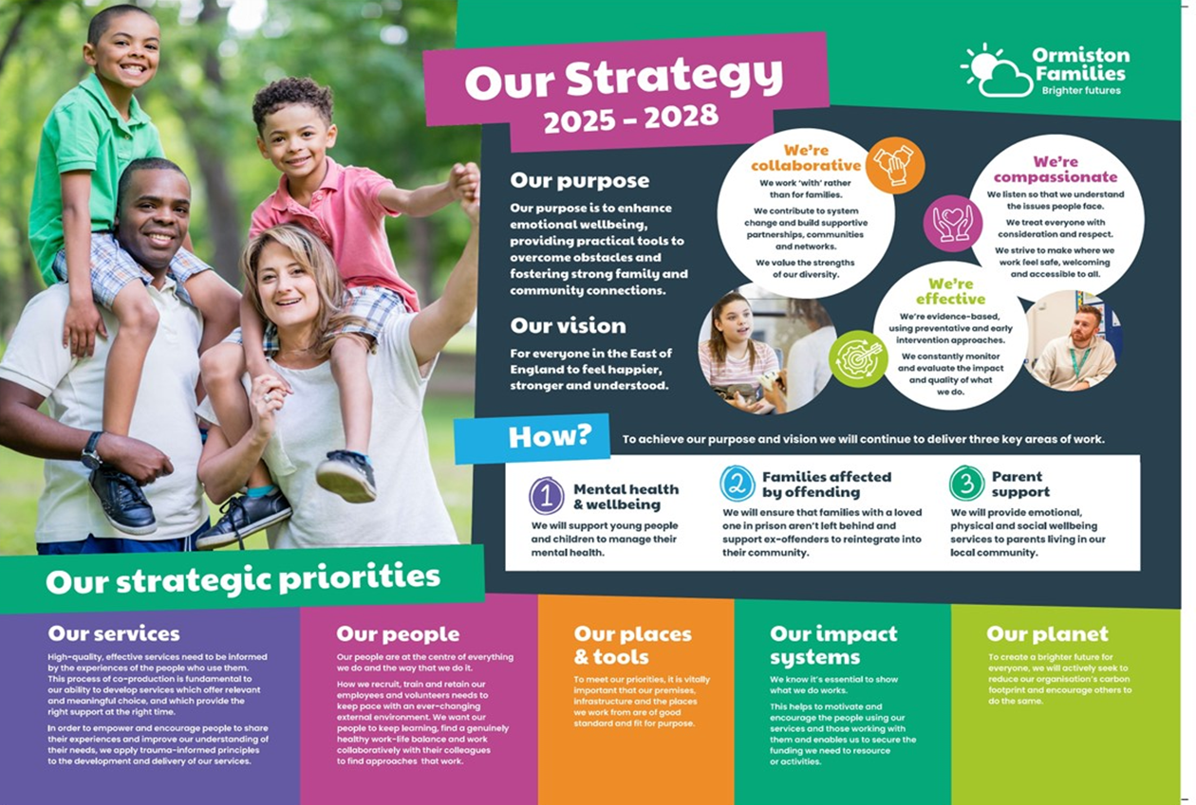
Administrator
Supporting Smiles
A message from our CEO, Bruce Leeke

Dear Applicant,

Thank you for your interest in the post of Administrator in our Supporting Smiles Service.

It’s an exciting time for our charity. After more than four decades of changing lives and strengthening communities in the East of England we continue to deliver highly impactful services that reflect our values of compassion, collaboration, and effectiveness. What we do benefits thousands of children and families every year and we are ambitious to build on our legacy.

We are constantly looking at new ways to improve the outcomes of our beneficiaries through co-production, innovation, and partnerships. Our people are at the heart of everything we do, acting as the conduit to brighter futures for the children and families we support. We hope that our approach inspires you to take the next step in your career with us.

Wishing you the best of luck with your application.

Best regards,


Bruce Leeke

Who Are Ormiston Families?

Ormiston Families is one of the leading charities working with children, young people and families in the East of England. We take early and preventative action to support families to be safe, healthy and resilient. All our services help people to build stronger networks, learn from experience and feel in control of their own wellbeing. We can only achieve this with the people who choose to work for us.

About Our Service
Our Supporting Smiles service provides professional mental health support to children and young people through our Therapeutic Pathway for 4–13-year-olds and 5–18-year-olds with our Children’s Wellbeing Practitioner team. Whether residing in Norfolk or Waveney or registered with a Norfolk or Waveney GP, we're here to offer therapeutic support to meet children and young people’s needs.

At Supporting Smiles, we believe in a needs-led approach, and our service name, "Supporting Smiles," was co-created with input from the children and families we support. Our holistic mental health and wellbeing support service encompasses the expertise of our therapeutic practitioners, counsellors, and children’s wellbeing practitioners. Together, we are committed to working alongside a network of support that extends beyond our walls and into the heart of the community.

About the role
The post holder plays a vital role in offering administrative support to the Supporting Smiles Team in its work with children, young people and their families. This varied role will involve general administrative duties, from offering information and guidance to parents and professionals during initial telephone enquiries to processing client referrals and presenting data to support governance. You will provide administrative support for the managers and therapists, including volunteers and students, ensuring information is held securely and confidentially in line with GDPR requirements.

About you

As the post holder, you will need experience of working in an administrative post, as well as experience of working with confidential and sensitive information.

This post is a part-time permanent position, working 22.5 hours per week (preferably to be worked on Wednesdays, Thursdays and Fridays). Salary is £24,570 per annum (£12.60 per hour – due to increase in April in line with the Real Living Wage). The location of the role is in our Norwich Hub based in central Norwich.

Safer Recruitment

Application Process / Post Requirement
You must demonstrate that you meet the competencies; experience, knowledge, skills, and qualifications, that are required for this role (see Job Description below).
You must complete and submit an online application form (via the ‘Work with Us’ section of our website) detailing in the personal statement section, how you meet the criteria.

Rights to Work in the UK (RTW) (in person or remote)
The Recruiting Manager will need to see the original documents providing proof of your right to work in the UK.
- UK Passport / Full UK Birth Certificate / Drivers Licence / Utilities Bill
(proof of address)
- EUSS Permanent Status or Pre-Status Share Code
- Current EU/EAA/Swiss Citizen Passport
- EU/EAA/Swiss Citizen Visa
- Home Office Certificate
- If the interview is held in person, we will verify hard copy documents which you will need to bring with you to the interview.
- If the interview is held remotely, you will need to email copies of your RTW documents to the Recruiting Manager before the interview. At the remote interview [Teams, Skype, Zoom] you will need to have the original hard copy documents available so the relevant checks can be undertaken.

Safeguarding and DBS Requirements for Your Role
Ormiston Families is committed to safeguarding and promoting the welfare of children, young people and adults at risk and expects all staff and volunteers to share this commitment. DBS checks or police vetting will be required for relevant posts.

Disclosure and Barring Service (DBS) Checks:
As this position meets the definition of regulated activity under the Protection of Freedom Act 2012, appointments to this post will be subject to an enhanced DBS check with barred list check.
- Employment can commence once the check has been satisfactorily completed.
- If you have a conviction on your DBS check, an assessment of the relevance and impact of the conviction in relation to the post will be done to determine if the job offer can be confirmed.
- It is a serious criminal offence to knowingly apply for posts when you have been barred from working with children/young people and/or vulnerable adults.
- Additional questions for roles working with children, young people, or vulnerable adults to be explored at interview.
- As this post involves working either with children and young people or vulnerable adults Warner or Safer Care motivational type questions may be asked during the interview process.
- These questions are asked to establish your suitability to work with vulnerable groups by understanding your attitude, behaviour, and responses to situations.
- The questions will relate to your inspiration for working with vulnerable groups, your ability to build relationships and your resilience when working with such groups and may also explore your attitude to the use of authority.
- If you feel you would find these questions about yourself difficult to respond to then you may wish to reflect upon your suitability for the post.

Disclosure
- Ormiston Families encourages all candidates called for interview to provide details of their criminal record at an early stage in the application process.
  - This information can be sent under separate, confidential cover to the Human Resources Team hr@ormistonfamilies.org.uk
  - Ormiston Families guarantees that this information will only be seen by those who need to see it as part of the recruitment process.
- Unless the nature of the position allows Ormiston Families to ask questions about your entire criminal record only questions about "unspent" convictions as defined in the Rehabilitation of Offenders Act 1974 will be asked.
- Ormiston Families will ensure that every subject of a DBS Disclosure is aware of the existence of the DBS Code of Practice and make a copy available on request.
- Ormiston Families undertakes to discuss any matter revealed in a Disclosure with the person seeking the position before withdrawing a conditional offer of employment.
- Having a criminal record will not necessarily bar you from working with Ormiston Families. This will depend on the nature of the position and the circumstances and background of the offences.

Qualification
- The Recruiting Manager will need to see the original copies of your qualification either in person or via video conference.
- If the interview is held in person, we will verify hard copy documents which you will need to bring with you to the interview.
- If the interview is held via video conference, you will need to email copies of your qualification to the Recruiting Manager before the interview. At the interview, you will need to have the original hard copy documents available so the relevant checks can be undertaken.
- If short-listed and you are required to hold a particular qualification for a post it is your responsibility to provide the relevant certification, to prove you are suitably qualified.
- Failure to produce documentary evidence of qualifications or undertake required courses/training may result in the termination of your employment.
- If a post requires you to take training or additional qualifications then, by accepting this post, you are agreeing to do the training or take the qualifications.

References
- If appointed, we will ask you for referee details which cover your past 3 years of employment, one of which must be your current/most recent employer.

Health Check
- If appointed and to ensure the post does not have a detrimental effect on your health or your health on your work, you will have to complete a health enquiry form, and may be required to have a medical via Occupational Health.
- This is to confirm that you are able to satisfactorily carry out the post without any impact on your health (taking account of any reasonable adjustments required).
- It will be separated from your application form and will not be seen by anyone involved in recruitment to this job.

GDPR / Data Protection:
- Ormiston Families is required by law to comply with the UK GDPR / Data Protection Act 2018.
- Employees have an important role to play in ensuring that personal information is processed lawfully and fairly.
- Personal information is information relating to a living individual who can be identified.
- It is each individual employee’s responsibility to handle all personal information properly no matter how it is collected, recorded and used, whether on paper, in a computer, or on other material.
- Personal information must not be disclosed to others unless authorised to do so.
- All personal /sensitive information will be sent to you via Egress encryption service or password protected.

Equal Opportunities:
- Ormiston Families is an equal opportunities employer.
- We value diversity and welcome applications from all sections of the community.
- We ask you to complete a monitoring form to help us monitor the diversity of applicants. It will be separated from your application form and will not be seen by anyone involved in recruitment to this job.
- The gender identity, disability, marital status, ethnic origin, age, pregnancy status, religion or belief, or sexual orientation of an applicant or employee does not affect the employment opportunities made available, except as permitted by legislation.
- In addition, applicants declaring a disability who meet the minimum (essential) criteria for a vacancy will be invited for interview.
- Ormiston Families seeks to ensure that all employees are selected, trained, and promoted on the basis of ability, the requirements of the post and other similar and objective criteria.

Any queries, please email: Tracy.horne@ormistonfamilies.org.uk

Ormiston Families reserves the right to close the vacancy early if we have received sufficient applications ahead of the closing date.

Information about working
for Ormiston Families

Job Title: Administrator

Hours of Work and Working Arrangements:
- This post is a part-time permanent position, working 22.5 hours per week (preferably to be worked on Wednesdays, Thursdays and Fridays) and covers 52 weeks per year.
- You may be required to work flexibly to meet the needs of the service which may include evenings and weekends.

Location:
- Your base will be our Norwich Hub.

Salary:
- The salary for this post is £24,570 per annum, based on 37.5 hours per week (£12.60 per hour – due to increase in April in line with the Real Living Wage).
- Salary is paid in 12 equal instalments on the 25th of each month directly into your bank account and covers work carried out in the calendar month.

Probationary Period:
- The post is subject to a probationary period of 6 months during which your progress will be monitored in accordance with agreed objectives.

Travelling Requirements for Your Role
- Ormiston Families positively encourages the use of technology to communicate and engage but in this role you may need to travel.
- You must either hold a full and current driving licence and have access to personal transport or meet the mobility requirements of the role through other reasonable and suitable means.
- Any mileage undertaken on behalf of Ormiston Families will be paid in accordance with our Expenses Policy and within Her Majesty’s Revenue and Customs guidelines.
- If you require a reasonable adjustment due to a disability to meet the travel requirements of this role, please speak with the contact detailed below.
- If you use your own vehicle for the purposes of work, you must ensure that your insurance policy covers you for this purpose.



Job Description

Job Title: Administrator
Service: Supporting Smiles
Location: Norwich Hub, 11 Prince of Wales Rd NR1 1BD

Job Purpose
Our Supporting Smiles service provides professional mental health support to children and young people through our Therapeutic Pathway for 4–13 year olds and 5–18 year olds with our Children’s Wellbeing Practitioner team. Whether residing in Norfolk or Waveney or registered with a Norfolk or Waveney GP, we’re here to offer therapeutic support to meet children and young people’s needs.

The post holder plays a vital role in offering administrative support to the Supporting Smiles Team in its work with children, young people and their families. This varied role will involve general administrative duties, from offering information and guidance to parents and professionals during initial telephone enquiries to processing client referrals and presenting data to support governance. You will provide administrative support for the managers and therapists, including volunteers and students, ensuring information is held securely and confidentially in line with GDPR requirements.
You will need experience of working in an administrative post, as well as experience of working with confidential and sensitive information.

Main Duties and Responsibilities
- To act as the first point of contact for service users of Supporting Smiles. This may include visitors arriving for appointments.
- To accurately record and process incoming and current referrals for the service.
- To accurately record and process incoming calls, emails and general correspondence.
- Answer initial client enquiries sensitively and empathetically.
- To input and maintain accurate and useable information on the Supporting Smiles recording system; Charity Log.
- Provide telephone support for the team, dealing with both straightforward and complex enquiries from a range of sources, including the therapists, clients, families and carers as well as teachers, social workers and healthcare professionals.
- Ensure telephone and email messages are communicated accurately and dealt with in an appropriate and timely manner.
- Assist with booking appointments as required.
- Provide administrative support to our volunteers and students.
- Take responsibility for the timely collection and presentation of data to support clinical outcomes and governance.
- Ensure information is held securely and confidentially in line with data protection requirements.
- Support the fundraising and promotion work of the service as appropriate.
- Demonstrate flexibility and support in undertaking office and other appropriate duties as directed by the Administration team Manager and Service Support Manager.
- To deal with incoming and outgoing correspondence and relay accurate information to the relevant team member.
- To provide administrative support including typing standard letters ensuring they are well presented.
- To monitor rates of referrals recevied and ensure regular updates are provided to the Administration team Manager on these rates as requested.
- To monitor cases which are to be closed to the service.
- To keep an up-to-date record of file purging.
- To respond to phone calls and queries from service users, other parts of the service and professionals from outside agencies, dealing with immediate queries or referring onto the most appropriate person.
- To undertake Health and Safety checks.
- To support the implementation of Supporting Smiles’ system for obtaining service users information and support the efficient running of the ERS (Charity Log) for collating this information.
- To undertake general office admin duties including typing/emails, scanning and photocopying.
- To support and liaise with clinical team colleagues regarding the booking of sessions and venues for our work.
- To support with the delivery of referrals needing to go to interface meetings.
- To be familiar with the Patient Outcome Database and confidently communicate regarding this with clients, including supporting any issues with log in and completion.
- To carry out any additional appropriate duties as instructed by the manager. To work within Ormiston Families’ mission and values and all policies and procedures, including Safeguarding, Equality and Diversity, Participation, Quality and Health and Safety. Comply with relevant external standards and Quality Marks.

Quality Assurance
When working on behalf of the charity and service, administrators must adhere to:
- Safeguarding policies.
- Professional, ethical and legal codes of practice and legislation relating to children, young people and families.
- Health and Safety policies.
- Equality policies.
- Confidentiality and data protection policies.

Generic Duties & Responsibilities
- To undertake any other reasonable duty, which is appropriate to the grade when requested by senior staff.
- To be familiar with and comply with all Ormiston Families policies, procedures, protocols and guidelines.
- To demonstrate an understanding and commitment to the charity’s values.
- You may be required to conduct other tasks based on the business needs.
Personal Specification

Qualifications
Essential | Desirable
An excellent communicator | Qualification in a therapeutic approach
Ability to manage own workload and work on own initiative within given guidelines
Supportive team player with a can-do attitude
Workplace resilience
Committed to inclusion and diversity

Experience
Essential | Desirable
Experience of working in an administrative post | Experience of working in a Children and Young Person’s Health service
Experience of working with confidential and sensitive information

Skills and Knowledge
Essential | Desirable
Excellent IT skills; Microsoft Word, Excel and Outlook. Skilled database user
Excellent organisation skills
Good literacy and numeracy skills
Excellent attention to detail
Knowledge of working with other agencies and professionals
Strong customer service skills
A good understanding of confidentiality and data protection

Professional and Personal Development
- All staff must ensure that they are aware of their responsibilities by attending mandatory training and our induction programme.
- All staff will have a formal appraisal with their manager at least every 12 months. Once performance/training objectives have been set, the staff member’s progress will be reviewed on a regular basis so that new objectives can be agreed and set, in order to maintain progress in the service delivery.
- All staff will be expected to take responsibility for their own professional development and will be supported to achieve development opportunities as appropriate.

Health and Safety
- All staff have a responsibility to maintain the health and safety of self and others within the performance of duties in accordance with health and safety policies, and to undertake specific health and safety responsibilities as directed. All staff have a responsibility to adhere to the risk management policies & procedures.
- All staff are required to contribute to the control of risk, and must report immediately any incident, accident or near miss involving service users, carers, staff, contractors or members of the public.

Confidentiality and Information Governance
- All staff may gain or have access to confidential information about the assessment and/or treatment of service users, information affecting the public, private or work related staff information, or charity matters. A breach of confidentiality will have occurred where any such information has been divulged, passed (deliberately or accidentally) or overheard by any unauthorised person or person(s). Breaches of confidentiality can result in disciplinary action, which may involve dismissal.
- All staff must maintain a high standard of quality in corporate and clinical record keeping, ensuring information is always recorded accurately, appropriately and kept up to date. Staff must only access information, whether paper, electronic or in other media which is authorised to them as part of their duties.
- All staff must ensure compliance with the Data Protection Act 2018 and the UK GDPR.

Safeguarding: Adults and Children (Section 11 of the Children Act 2004)
- Every member of staff has a responsibility to be aware of and follow at all times, the relevant national and local policy in relation to safeguarding children and safeguarding adults.
- Safeguarding and DBS requirements for your role:
- Ormiston Families is committed to safeguarding and promoting the welfare of children, young people and adults at risk and expects all staff and volunteers to share this commitment. DBS checks or police vetting will be required for relevant posts.

Senior Managers
- Under Section 11 of the Children Act senior managers have responsibility for ensuring that service developments take into account the promotion of welfare and is informed by the views of children and families; providing training on safeguarding for all staff; recruiting safely; ensuring there is effective inter-agency working and information sharing.


Freedom of Information (FOI)
- All members of staff must be aware of their responsibilities under the Freedom of Information (FOI) Act 2000. The Act gives individuals or organisations the right to request information held by the charity. Staff must manage information they hold in such a way that meets the requirements of the Act. All requests for disclosures under the Act must be passed to the Privacy Officer.

Data Quality
- The Charity recognises the role of reliable information in the delivery & development of its services and in assuring robust clinical and corporate governance. Data quality is central to this and the availability of complete, comprehensive, accurate and timely data is an essential component in the provision of high-quality mental health services. It is therefore the responsibility of all staff to ensure that where appropriate, information is recorded, at all times, in line with the charity’s policy and procedures for data quality.
- This job description seeks to provide an outline of the duties and responsibilities of the post. It is not a definitive document and does not form part of the main statement of terms and conditions. The job description will be reviewed as part of the annual appraisal process and will be used as the basis for setting objectives.

Benefits & Recognition
All benefits are discretionary, and Ormiston Families reserves the right to change or amend benefits at any given time.
Cycle to Work
- Cycle to Work allows you to order a new bike, equipment or both up to the value of £1,000 which you can pay back through your salary to make tax savings.

Annual Leave Entitlement:
- The basic annual leave entitlement is 27 days plus additional leave for employees who have completed 1 year’s service up to a maximum of 30 days
- Part-time employees receive a pro-rata allowance according to the number of hours they work per week.
- Ability to buy and sell up to 5 days’ annual leave within any leave year. (All leave must be taken within the year it is purchased including any agreed leave brought forward from the previous year.)

Group Life Assurance:
- Ormiston Families provides a death in service benefit to all permanent employees.
Occupational Sick Pay Scheme:
- Ormiston Families operates an occupational sick pay scheme in addition to statutory sick pay.

Pension:
- Ormiston Families provides a Group Personal Pension Scheme with up to 9% of gross salary employer contribution for any employee where they match the level of contribution.

Sponsorship:
- Ormiston Families provides the opportunity to apply for sponsorship to employees who have completed their probationary period and been in post for at least 12 months to undertake nationally accredited or chartered certification awarded by professional associations.

Employee Assistance Programme:
- Ormiston Families provides a comprehensive employee assistance programme which offers free and confidential access to telephone and face to face counselling (up to 6 sessions), financial and legal advice and assistance in finding information about a wide range of subjects from childcare to moving to a new house.

Employee Discount Scheme:
- The Hive is a savings platform which can be accessed by employees to make everyday purchases at reduced costs. Employees can save money by purchasing reloadable cards, obtain cashback through online purchases, and make savings in many stores.

Your Wellbeing:
- We have trained Mental Health First Aiders who form our Wellbeing Team, promoting mental and physical health. Ormiston Families has also signed the pledge to support our employees going through the menopause in the workplace.

The Wellbeing Centre:
- Accessed via The Hive, the Wellbeing Centre provides education, support and tools to help you live a healthier and happier life.

Pets in the Workplace:
- We are a dog-friendly employer, which means that from time to time we allow colleagues to bring their pets into our workplaces. If you would like a copy of our Pets in the Workplace policy or would like to discuss this in more detail, please contact our HR team.


We build supportive partnerships, communities and networks

