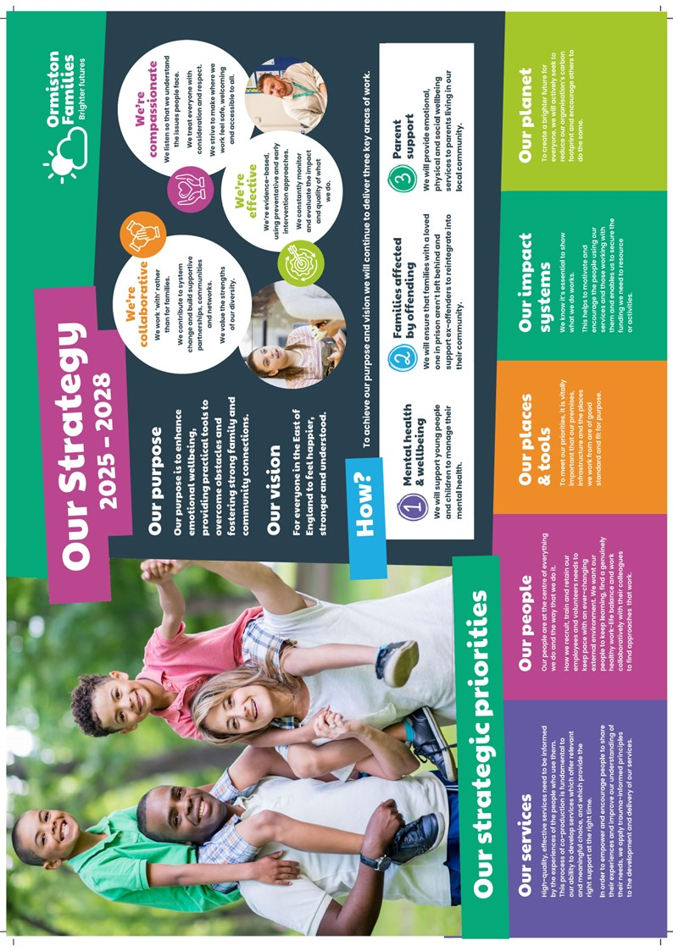
Practitioner
Mpower Norfolk (North Norfolk)

A message from our CEO, Bruce Leeke

Dear Applicant,

Thank you for your interest in the post of Practitioner in our Mpower Norfolk Service.

It’s an exciting time for our charity. After more than four decades of changing lives and strengthening communities in the East of England we continue to deliver highly impactful services that reflect our values of compassion, collaboration, and effectiveness. What we do benefits thousands of children and families every year and we are ambitious to build on our legacy.

We are constantly looking at new ways to improve the outcomes of our beneficiaries through co-production, innovation, and partnerships. Our people are at the heart of everything we do, acting as the conduit to brighter futures for the children and families we support. We hope that our approach inspires you to take the next step in your career with us.

Wishing you the best of luck with your application.

Best regards,


Bruce Leeke

Who Are Ormiston Families?

Ormiston Families is one of the leading charities working with children, young people and families in the East of England. We take early and preventative action to support families to be safe, healthy and resilient. All our services help people to build stronger networks, learn from experience and feel in control of their own wellbeing. We can only achieve this with the people who choose to work for us.

About Our Mpower Service
Mpower Norfolk supports mothers (and where appropriate their partners) whose children have been removed into care where at least one child was removed in the last three years and at least one child was aged three or under at the point of removal.

We support people by building safe and trusting relationships, taking time to understand their story, their needs, and their preferences, and helping them to set and work towards goals. Empathy and understanding are core to how we work, as the type of grief and loss experienced by the people we support is widely misunderstood.

Our work is commissioned by Norfolk Public Health and Children’s Services, with success measured against the percentage of people making progress towards their goals, moving onto or maintaining contraception, not having a pregnancy in service, engaging in other appropriate services, and having a planned closure.

Mpower does not help reunite parents with their children. Our support can last for up to 24 months and in some cases longer.

About the role

As a Practitioner, you will support people by building safe and trusting relationships, taking time to understand their story, their needs, and their preferences, and helping them to set and work towards goals.

You will be joining a highly supportive and caring team with lots of opportunities to connect with colleagues and reflect on your practice. In your case work, you will work with independence and self-direction, drawing on the perspectives and knowledge of colleagues. You will need to use sensitive but persistent outreach to remove the barriers to engagement for those you support.

The support you offer will last for up to 24 months and in some exceptional cases longer. Ultimately, your support will help people to make the meaningful changes they want to, rebuild their lives, and reduce the number of children being removed into care.

You will be joining a service that has been running successfully for over ten years. Recently, Mpower successfully attained the Working With Trauma: Trauma Aware quality mark, so you will play a part in the implementation of our plans to become a trauma-informed service.

About you

It is important that you have experience of working with people who have experienced complex trauma in a person-centred way. You will need to be confident lone working and making decisions around support. You will also need the skills to manage your own caseload, including completing all case recording paperwork. It is essential that you have your own vehicle and can travel within Norfolk.

Your post will be home-based, covering North Norfolk. Locations covered by the post include, but are not limited to, Wells-next-the-Sea, Fakenham, Cromer, North Walsham, Stalham, Wroxham, Sea Palling, and Ludham.
.

Safer Recruitment

Application Process / Post Requirement
You must demonstrate that you meet the competencies; experience, knowledge, skills, and qualifications, that are required for this role (see Job Description below).
You must complete and submit an online application form (via the ‘Work with Us’ section of our website) detailing in the personal statement section, how you meet the criteria.

Rights to Work in the UK (RTW) (in person or remote)
The Recruiting Manager will need to see the original documents providing proof of your right to work in the UK.
- UK Passport / Full UK Birth Certificate / Drivers Licence / Utilities Bill
(proof of address)
- EUSS Permanent Status or Pre-Status Share Code
- Current EU/EAA/Swiss Citizen Passport
- EU/EAA/Swiss Citizen Visa
- Home Office Certificate
- If the interview is held in person, we will verify hard copy documents which you will need to bring with you to the interview.
- If the interview is held remotely, you will need to email copies of your RTW documents to the Recruiting Manager before the interview. At the remote interview [Teams, Skype, Zoom] you will need to have the original hard copy documents available so the relevant checks can be undertaken.

Safeguarding and DBS Requirements for Your Role
Ormiston Families is committed to safeguarding and promoting the welfare of children, young people and adults at risk and expects all staff and volunteers to share this commitment. DBS checks or police vetting will be required for relevant posts.

Disclosure and Barring Service (DBS) Checks:
- As this position meets the definition of regulated activity under the Protection of Freedom Act 2012, appointments to this post will be subject to an enhanced DBS check with barred list check.
- Employment can commence once the check has been satisfactorily completed.
- If you have a conviction on your DBS check, an assessment of the relevance and impact of the conviction in relation to the post will be done to determine if the job offer can be confirmed.
- It is a serious criminal offence to knowingly apply for posts when you have been barred from working with children/young people and/or vulnerable adults.
- Additional questions for roles working with children, young people, or vulnerable adults to be explored at interview.
- As this post involves working either with children and young people or vulnerable adults Warner or Safer Care motivational type questions may be asked during the interview process.
- These questions are asked to establish your suitability to work with vulnerable groups by understanding your attitude, behaviour, and responses to situations.
- The questions will relate to your inspiration for working with vulnerable groups, your ability to build relationships and your resilience when working with such groups and may also explore your attitude to the use of authority.
- If you feel you would find these questions about yourself difficult to respond to then you may wish to reflect upon your suitability for the post.

Disclosure
- Ormiston Families encourages all candidates called for interview to provide details of their criminal record at an early stage in the application process.
  - This information can be sent under separate, confidential cover to the Human Resources Team hr@ormistonfamilies.org.uk
  - Ormiston Families guarantees that this information will only be seen by those who need to see it as part of the recruitment process.
- Unless the nature of the position allows Ormiston Families to ask questions about your entire criminal record only questions about "unspent" convictions as defined in the Rehabilitation of Offenders Act 1974 will be asked.
- Ormiston Families will ensure that every subject of a DBS Disclosure is aware of the existence of the DBS Code of Practice and make a copy available on request.
- Ormiston Families undertakes to discuss any matter revealed in a Disclosure with the person seeking the position before withdrawing a conditional offer of employment.
- Having a criminal record will not necessarily bar you from working with Ormiston Families. This will depend on the nature of the position and the circumstances and background of the offences.

Qualification
- The Recruiting Manager will need to see the original copies of your qualification either in person or via video conference.
- If the interview is held in person, we will verify hard copy documents which you will need to bring with you to the interview.
- If the interview is held via video conference, you will need to email copies of your qualification to the Recruiting Manager before the interview. At the interview, you will need to have the original hard copy documents available so the relevant checks can be undertaken.
- If short-listed and you are required to hold a particular qualification for a post it is your responsibility to provide the relevant certification, to prove you are suitably qualified.
- Failure to produce documentary evidence of qualifications or undertake required courses/training may result in the termination of your employment.
- If a post requires you to take training or additional qualifications then, by accepting this post, you are agreeing to do the training or take the qualifications.

References
- If appointed, we will ask you for referee details which cover your past 3 years of employment, one of which must be your current/most recent employer.

Health Check
- If appointed and to ensure the post does not have a detrimental effect on your health or your health on your work, you will have to complete a health enquiry form, and may be required to have a medical via Occupational Health.
- This is to confirm that you are able to satisfactorily carry out the post without any impact on your health (taking account of any reasonable adjustments required).
- It will be separated from your application form and will not be seen by anyone involved in recruitment to this job.

GDPR / Data Protection:
- Ormiston Families is required by law to comply with the UK GDPR / Data Protection Act 2018.
- Employees have an important role to play in ensuring that personal information is processed lawfully and fairly.
- Personal information is information relating to a living individual who can be identified.
- It is each individual employee’s responsibility to handle all personal information properly no matter how it is collected, recorded and used, whether on paper, in a computer, or on other material.
- Personal information must not be disclosed to others unless authorised to do so.
- All personal /sensitive information will be sent to you via Egress encryption service or password protected.

Equal Opportunities:
- Ormiston Families is an equal opportunities employer.
- We value diversity and welcome applications from all sections of the community.
- We ask you to complete a monitoring form to help us monitor the diversity of applicants. It will be separated from your application form and will not be seen by anyone involved in recruitment to this job.
- The gender identity, disability, marital status, ethnic origin, age, pregnancy status, religion or belief, or sexual orientation of an applicant or employee does not affect the employment opportunities made available, except as permitted by legislation.
- In addition, applicants declaring a disability who meet the minimum (essential) criteria for a vacancy will be invited for interview.
- Ormiston Families seeks to ensure that all employees are selected, trained, and promoted on the basis of ability, the requirements of the post and other similar and objective criteria.

Any queries, please email: christian.iszchak@ormistonfamilies.org.uk
or call: 07719 973 027

Ormiston Families reserves the right to close the vacancy once we have received sufficient applications, so interested candidates are encourage to apply as soon as possible.

Information about working
for Ormiston Families

Job Title: Practitioner – Mpower Norfolk

Duration:
The post advertised is a part-time post; 21 hours per week with flexible or agile working.

Hours of Work and Working Arrangements:
- This post is full-time and will involve working 21 hours per week between Monday to Friday, covering 52 weeks per year.
- The normal working week is 35 hours, Monday to Friday and covers 52 weeks per year.
- You will be required to work flexibly to meet the needs of the service which may sometimes include evenings and weekends.

Location:
- This post is home-based, covering North Norfolk.

- Locations covered by the post include, but are not limited to, Wells-next-the-Sea, Fakenham, Cromer, North Walsham, Stalham, Wroxham, Sea Palling, and Ludham.

Salary:
- £15,528 per annum based on 21 hours per week (FTE of £25,880 per annum based on 35 hours per week).
- Salary is paid in 12 equal instalments on the 25th of each month directly into your bank account and covers work carried out in the calendar month.

Probationary Period:
- The post is subject to a probationary period of 6 months during which your progress will be monitored in accordance with agreed objectives.

Travelling Requirements for Your Role
- Ormiston Families positively encourages the use of technology to communicate and engage but in this role you will need to travel.
- You must either hold a full and current driving licence and have access to personal transport or meet the mobility requirements of the role through other reasonable and suitable means.
- Any mileage undertaken on behalf of Ormiston Families will be paid in accordance with our Expenses Policy and within His Majesty’s Revenue and Customs guidelines.
- If you require a reasonable adjustment due to a disability to meet the travel requirements of this role, please speak with the contact detailed below.
- If you use your own vehicle for the purposes of work, you must ensure that your insurance policy covers you for this purpose.



Job Description

Job Title: Practitioner
Service: Mpower Norfolk
Location: Home-based, covering North Norfolk

Job Purpose
To support people whose children have been removed from their care by building safe and trusting relationships, taking time to understand their story, their needs, and their preferences, and helping them to set and work towards goals.
Ultimately, your support will help people to make the meaningful changes they want to, rebuild their lives, and reduce the number of children being removed into care.

Main Duties and Responsibilities
- Work in a person-centred way with those you support, developing safe and trusting relationships, taking time to understand people’s needs and preferences, and working at a pace that works for them.
- Apply the principles of trauma-informed practice (safety, trustworthiness, choice, collaboration, empowerment) in all you do, using reflective spaces with colleagues to consider and work through the challenges of doing this.
- Undertake sensitive assessments of people’s needs to collaboratively set and work towards strengths-based goals.
- Meaningfully engage in reflective practice, promoting the value of reflection with your immediate colleagues, the wider organisation, and other professionals.
- Plan and deliver group work, applying the principles of good group work practice and prioritising choice and collaboration in how groups are planned and delivered.
- Take a sensitive, flexible, and persistent approach to engaging with people, recognising the many barriers to engagement that can come with complex histories of trauma.
- Empower those you support to engage with a range of other services and organisations, identifying what barriers to engagement might be and actively support them and the services they’re trying to access to overcome these.
- Build and maintain a strong network of professional colleagues from across a variety of providers, including charitable and statutory services.
- Take the lead in a multi-agency way of working, putting the people you support at the heart of this and advocating for their right to choice in the support they receive from services.

Generic Responsibilities
- Embed a continuous learning ethos within individual and team practice, including involvement in reflective practice discussions and contributing to service development.
- Keep factual and accurate records in line with Ormiston’s processes and funder requirements, assisting colleagues with data recording and reporting, and inputting into reports as requested.
- Ensure all practice matters relating to child protection or vulnerable adults are dealt with promptly and in line with local and internal safeguarding processes.

Generic Duties
- To undertake any other reasonable duty, which is appropriate to the grade when requested by senior staff.
- To be familiar with and comply with all Ormiston Families policies, procedures, protocols and guidelines.
- To demonstrate an understanding and commitment to the charity’s values.
- You may be required to conduct other tasks based on the business needs.

Personal Specification

Qualifications
Essential | Desirable
Relevant CPD, such as trauma-informed practice, working with disordered attachment, motivational interviewing, solution-focussed therapy, etc. | NVQ 4 or equivalent in relevant subject, e.g. Health & Social Care, Youth Work, etc
Safeguarding Core Programme or equivalent. | Adults Safeguarding Awareness training or equivalent.
A full driving license. (You must be able to travel independently within the county and have access to your own vehicle. Transporting those we support in your vehicle will be necessary.)

Experience
Essential | Desirable
Work in a relevant setting, e.g. social work, family work, mental health, criminal justice, etc. | Case management, including completing assessments, working towards goals, and/or supporting people to engage with other services.
Directly supporting people who have experienced complex trauma in a person-centred way.
Collaborating on complex safeguarding cases.

Abilities and Knowledge

Essential | Desirable
Able to work intensively with people who have experienced complex trauma. | Understanding of care proceedings, including child protection procedures.
Effective and adaptable communication skills with the ability to discuss complex issues with sensitivity. | Detailed understanding and/or experience of using a strength-based approach and/or trauma-informed practice.
Able to lone work safely using a dynamic risk assessment. | Able to work with people in a goal-based way where the barriers to change are varied, complex, and require deep understanding.
Able to manage own workload and work on own initiative, balancing direct work with those you support with administrative tasks, team collaboration, and other duties. | Able to develop local networks to promote service understanding, generate referrals and identify alternative support for people.
Able to openly and honestly reflect on practice.
The necessary computer literacy skills to record clear, accurate information in a variety of formats.
A good understanding of equal opportunities, diversity, health and safety, and data protection.

Professional and Personal Development
- All staff must ensure that they are aware of their responsibilities by attending mandatory training and our induction programme.
- All staff will have a formal appraisal with their manager at least every 12 months. Once performance/training objectives have been set, the staff member’s progress will be reviewed on a regular basis so that new objectives can be agreed and set, in order to maintain progress in the service delivery.
- All staff will be expected to take responsibility for their own professional development and will be supported to achieve development opportunities as appropriate.

Health and Safety
- All staff have a responsibility to maintain the health and safety of self and others within the performance of duties in accordance with health and safety policies, and to undertake specific health and safety responsibilities as directed. All staff have a responsibility to adhere to the risk management policies & procedures.
- All staff are required to contribute to the control of risk, and must report immediately any incident, accident or near miss involving service users, carers, staff, contractors or members of the public.

Confidentiality and Information Governance
- All staff may gain or have access to confidential information about the assessment and/or treatment of service users, information affecting the public, private or work related staff information, or charity matters. A breach of confidentiality will have occurred where any such information has been divulged, passed (deliberately or accidentally) or overheard by any unauthorised person or person(s). Breaches of confidentiality can result in disciplinary action, which may involve dismissal.
- All staff must maintain a high standard of quality in corporate and clinical record keeping, ensuring information is always recorded accurately, appropriately and kept up to date. Staff must only access information, whether paper, electronic or in other media which is authorised to them as part of their duties.
- All staff must ensure compliance with the Data Protection Act 2018 and the UK GDPR.
Safeguarding: Adults and Children (Section 11 of the Children Act 2004)
- Every member of staff has a responsibility to be aware of and follow at all times, the relevant national and local policy in relation to safeguarding children and safeguarding adults.
- Safeguarding and DBS requirements for your role:
- Ormiston Families is committed to safeguarding and promoting the welfare of children, young people and adults at risk and expects all staff and volunteers to share this commitment. DBS checks or police vetting will be required for relevant posts.

Senior Managers
- Under Section 11 of the Children Act senior managers have responsibility for ensuring that service developments take into account the promotion of welfare and is informed by the views of children and families; providing training on safeguarding for all staff; recruiting safely; ensuring there is effective inter-agency working and information sharing.

Freedom of Information (FOI)
- All members of staff must be aware of their responsibilities under the Freedom of Information (FOI) Act 2000. The Act gives individuals or organisations the right to request information held by the charity. Staff must manage information they hold in such a way that meets the requirements of the Act. All requests for disclosures under the Act must be passed to the Privacy Officer.

Data Quality
- The Charity recognises the role of reliable information in the delivery & development of its services and in assuring robust clinical and corporate governance. Data quality is central to this and the availability of complete, comprehensive, accurate and timely data is an essential component in the provision of high-quality mental health services. It is therefore the responsibility of all staff to ensure that where appropriate, information is recorded, at all times, in line with the charity’s policy and procedures for data quality.
- This job description seeks to provide an outline of the duties and responsibilities of the post. It is not a definitive document and does not form part of the main statement of terms and conditions. The job description will be reviewed as part of the annual appraisal process and will be used as the basis for setting objectives.

Benefits & Recognition
All benefits are discretionary, and Ormiston Families reserves the right to change or amend benefits at any given time.
Cycle to Work
- Cycle to Work allows you to order a new bike, equipment or both up to the value of £1,000 which you can pay back through your salary to make tax savings.

Annual Leave Entitlement:
- The basic annual leave entitlement is 27 days plus additional leave for employees who have completed 1 year’s service up to a maximum of 30 days
- Part-time employees receive a pro-rata allowance according to the number of hours they work per week.
- Ability to buy and sell up to 5 days’ annual leave within any leave year. (All leave must be taken within the year it is purchased including any agreed leave brought forward from the previous year.)

Group Life Assurance:
- Ormiston Families provides a death in service benefit to all employees up to the age of 70, which includes and covers permanent, fixed-term and as & when contracted staff..
Occupational Sick Pay Scheme:
- Ormiston Families operates an occupational sick pay scheme in addition to statutory sick pay.

Pension:
- Ormiston Families provides a Group Personal Pension Scheme with up to 9% of gross salary employer contribution for any employee where they match the level of contribution.

Sponsorship:
- Ormiston Families provides the opportunity to apply for sponsorship to employees who have completed their probationary period and been in post for at least 12 months to undertake nationally accredited or chartered certification awarded by professional associations.
Employee Assistance Programme:
- Ormiston Families provides a comprehensive employee assistance programme which offers free and confidential access to telephone and face to face counselling (up to 6 sessions), financial and legal advice and assistance in finding information about a wide range of subjects from childcare to moving to a new house.

The Hive:
- The Hive is a savings platform which can be accessed by employees to make everyday purchases at reduced costs. Employees can save money by purchasing reloadable cards, obtain cashback through online purchases, and make savings in some stores.

The Wellbeing Centre:
- Accessed via The Hive, the Wellbeing Centre provides education, support and tools to help you live a healthier and happier life.



We build supportive partnerships, communities and networks

