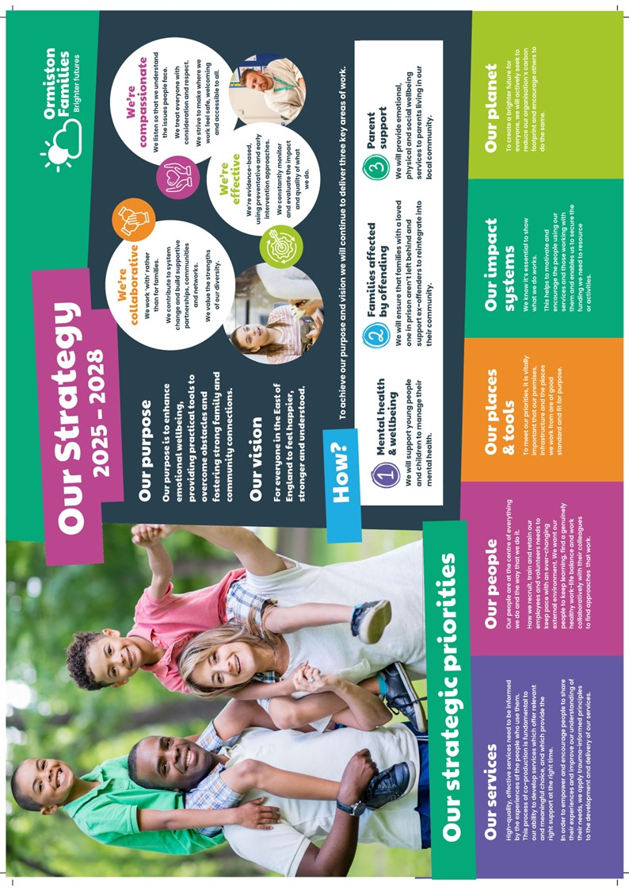
Who Are Ormiston Families?
Fundraising Manager
Income Generation

Ormiston Families is one of the leading charities working with children, young people, and families in the East of England. We take early and preventative action to support families to be safe, healthy, and resilient. All our services help people to build stronger networks, learn from experience and feel in control of their own wellbeing. We can only achieve this with the people who choose to work for us.

About Income Generation
The Income Generation team plays a vital role in securing the funding needed for Ormiston Families to run its services.
The team looks after fundraising for the charity, including trusts, events and community fundraising. It also looks after our Communications and Marketing.
About the role
To lead and grow the trusts and foundations fundraising and grant administration function, managing a high-performing team and driving strategic income growth, to achieve financial targets. You will also spearhead innovative fundraising initiatives to diversify revenue streams and support the charity’s long-term sustainability.

About you
You will be someone passionate about building powerful relationships with an understanding of how our messaging and storytelling can connect with existing and potential supporters. The job holder must have a strong understanding of what motivates people to support Ormiston Families and how to attract them to our cause.
Safer Recruitment

Application Process / Post Requirement
You must demonstrate that you meet the competencies; experience, knowledge, skills, and qualifications, that are required for this role (see Job Description below).
You must complete and submit an online application form (via the ‘Work with Us’ section of our website) detailing in the personal statement section, how you meet the criteria.

Rights to Work in the UK (RTW) (in person or remote)
The Recruiting Manager will need to see the original documents providing proof of your right to work in the UK.
- UK Passport / Full UK Birth Certificate / Drivers Licence / Utilities Bill
(proof of address)
- EUSS Permanent Status or Pre-Status Share Code
- Current EU/EAA/Swiss Citizen Passport
- EU/EAA/Swiss Citizen Visa
- Home Office Certificate
- If the interview is held in person, we will verify hard copy documents which you will need to bring with you to the interview.
- If the interview is held remotely, you will need to email copies of your RTW documents to the Recruiting Manager before the interview. At the remote interview [Teams, Skype, Zoom] you will need to have the original hard copy documents available so the relevant checks can be undertaken.

Safeguarding and DBS Requirements for Your Role
Ormiston Families is committed to safeguarding and promoting the welfare of children, young people and adults at risk and expects all staff and volunteers to share this commitment. DBS checks or police vetting will be required for relevant posts.

Disclosure
- Ormiston Families encourages all candidates called for interview to provide details of their criminal record at an early stage in the application process.
  - This information can be sent under separate, confidential cover to the Human Resources Team hr@ormistonfamilies.org.uk
  - Ormiston Families guarantees that this information will only be seen by those who need to see it as part of the recruitment process.
- Unless the nature of the position allows Ormiston Families to ask questions about your entire criminal record only questions about "unspent" convictions as defined in the Rehabilitation of Offenders Act 1974 will be asked.
- Ormiston Families will ensure that every subject of a DBS Disclosure is aware of the existence of the DBS Code of Practice and make a copy available on request.
- Ormiston Families undertakes to discuss any matter revealed in a Disclosure with the person seeking the position before withdrawing a conditional offer of employment.
- Having a criminal record will not necessarily bar you from working with Ormiston Families. This will depend on the nature of the position and the circumstances and background of the offences.

Qualification
- The Recruiting Manager will need to see the original copies of your qualification either in person or via video conference.
- If the interview is held in person, we will verify hard copy documents which you will need to bring with you to the interview.
- If the interview is held via video conference, you will need to email copies of your qualification to the Recruiting Manager before the interview. At the interview, you will need to have the original hard copy documents available so the relevant checks can be undertaken.
- If short-listed and you are required to hold a particular qualification for a post it is your responsibility to provide the relevant certification, to prove you are suitably qualified.
- Failure to produce documentary evidence of qualifications or undertake required courses/training may result in the termination of your employment.
- If a post requires you to take training or additional qualifications then, by accepting this post, you are agreeing to do the training or take the qualifications.

References
- If appointed, we will ask you for referee details which cover your past 3 years of employment, one of which must be your current/most recent employer.

Health Check
- If appointed and to ensure the post does not have a detrimental effect on your health or your health on your work, you will have to complete a health enquiry form, and may be required to have a medical via Occupational Health.
- This is to confirm that you are able to satisfactorily carry out the post without any impact on your health (taking account of any reasonable adjustments required).
- It will be separated from your application form and will not be seen by anyone involved in recruitment to this job.

UK GDPR / Data Protection:
- Ormiston Families is required by law to comply with the UK GDPR / Data Protection Act 2018.
- Employees have an important role to play in ensuring that personal information is processed lawfully and fairly.
- Personal information is information relating to a living individual who can be identified.
- It is each individual employee’s responsibility to handle all personal information properly no matter how it is collected, recorded, and used, whether on paper, in a computer, or on other material.
- Personal information must not be disclosed to others unless authorised to do so.
- All personal /sensitive information will be sent to you via Egress encryption service or password protected.

Equal Opportunities:
- Ormiston Families is an equal opportunities employer.
- We value diversity and welcome applications from all sections of the community.
- We ask you to complete a monitoring form to help us monitor the diversity of applicants. It will be separated from your application form and will not be seen by anyone involved in recruitment to this job.
- The gender identity, disability, marital status, ethnic origin, age, pregnancy status, religion or belief, or sexual orientation of an applicant or employee does not affect the employment opportunities made available, except as permitted by legislation.
- In addition, applicants declaring a disability who meet the minimum (essential) criteria for a vacancy will be invited for interview.
- Ormiston Families seeks to ensure that all employees are selected, trained, and promoted on the basis of ability, the requirements of the post and other similar and objective criteria.

Any queries, please email: Kate.higgs@ormistonfamilies.org.uk

Ormiston Families reserves the right to close the vacancy early if we have received sufficient applications ahead of the closing date.

Information about working
for Ormiston Families

Job Title: Fundraising Manager

Duration
The post advertised is permanent, with flexible or agile working.

Hours of Work and Working Arrangements:
- The normal working week is 35 hours, Monday to Friday and covers 52 weeks per year.
- You will be required to work flexibly to meet the needs of the service which may include evenings and weekends.

Location:
- Your base will be hybrid with 2 days in the Ipswich office.

Salary:
- The salary for this post is £44,115 per annum, based on 35 hours per week.
- Salary is paid in 12 equal instalments on the 25th of each month directly into your bank account and covers work carried out in the calendar month.

Probationary Period:
- The post is subject to a probationary period of 6 months during which your progress will be monitored in accordance with agreed objectives.

Travelling Requirements for Your Role
- Ormiston Families positively encourages the use of technology to communicate and engage but in this role you may need to travel.
- You must either hold a full and current driving licence and have access to personal transport or meet the mobility requirements of the role through other reasonable and suitable means.
- Any mileage undertaken on behalf of Ormiston Families will be paid in accordance with our Expenses Policy and within Her Majesty’s Revenue and Customs guidelines.
- If you require a reasonable adjustment due to a disability to meet the travel requirements of this role, please speak with the contact detailed below.
- If you use your own vehicle for the purposes of work, you must ensure that your insurance policy covers you for this purpose.



Job Description

Job Title: Fundraising Manager
Service: Income Generation
Location: Hybrid with 2 days in the Ipswich office

Job Purpose
To lead and grow the trusts and foundations fundraising and grant administration function, managing a high-performing team and driving strategic income growth, to achieve financial targets. You will also spearhead innovative fundraising initiatives to diversify revenue streams and support the charity’s long-term sustainability.

Main Duties and Responsibilities
Trusts & Foundations
- Develop and implement a robust strategy for trusts and foundations fundraising.
- Manage and mentor a team of fundraisers, setting KPIs and ensuring professional development.
- Oversee the pipeline of prospects, applications, and reporting to funders.
- Regularly apply for funding from trusts and foundations and nurture a portfolio of designated trusts.
- Build and maintain relationships with key grant-makers and philanthropic foundations.
- Ensure compliance with grant conditions and reporting requirements.
- Liaise regularly with service managers and work closely with services
- to develop new project ideas and expand existing ones in line with Ormiston Families strategy.
Grant Programme Oversight
- Lead the Provide Community grant programme, managing the full grant lifecycle from application to evaluation.
- Assess applications in line with the Provide Community grant guidelines and present applications to the independent grants panel.
- Act as the primary liaison for funders, overseeing due diligence, panel preparation, monitoring, and impact reporting.
- Ensure strong applicant relationships and uphold high standards of accountability and transparency.
- Work closely with the finance team to ensure all financial checks and payments are made in accordance with Provide Community time frames.
Strategic Fundraising Development
- Working alongside the income generation management team, identify and pilot new fundraising initiatives that deliver a maximum return on investment.
- Collaborate with senior leadership to align fundraising with organisational goals.
- Monitor sector trends and funding opportunities to inform strategy.
Other Responsibilities
- Be an expert user of Raisers Edge/NXT and Flexigrant, ensuring accurate data management and compliance with UK GDPR, the Data Protection Act 2018, and Ormiston Families’ policies.
- Participate actively in team and organisational-wide meetings.
- Maintain up-to-date knowledge of local, regional, and national charitable activity.
- Attend external networking events to build sector relationships.
- Undertake ad hoc tasks and responsibilities as directed by the Director of Income Generation and Marketing.
- Uphold Ormiston Families’ mission, values, and all relevant policies including Safeguarding, Equality and Diversity, Participation, Quality, and Health & Safety.

General Duties
- Liaise with staff across the charity to stay informed about our services and their impact.
- Work with colleagues in our Data and Insight to team to ensure access to the latest data.
- Stay up to date with latest developments in fundraising and marketing to ensure best practice.
- Undertake training courses – both in-house and external – when necessary to keep skills up to date.
- Undertake service visits on a schedule agreed with the Head of Communications and Marketing.

Personal Specification

Qualifications
Essential | Desirable
Relevant degree or qualification

Experience
Essential | Desirable
Proven track record of securing significant income from trusts and foundations. | Experience of developing responses to statutory tenders
Experience managing a fundraising team or function.
Proficiency in using fundraising databases, particularly Raisers Edge/NXT and Flexigrant.

Abilities and Knowledge

Essential | Desirable
Strong strategic planning and project management skills.
Excellent written and verbal communication, with the ability to craft compelling funding proposals.
Understanding of grant-making processes, due diligence, and impact reporting.
Knowledge of UK GDPR and data protection compliance in a fundraising context.
Ability to build and maintain relationships with funders and stakeholders.
Commitment to the values and mission of Ormiston Families.

Professional and Personal Development
- All staff must ensure that they are aware of their responsibilities by attending mandatory training and our induction programme.
- All staff will have a formal appraisal with their manager at least every 12 months. Once performance/training objectives have been set, the staff member’s progress will be reviewed on a regular basis so that new objectives can be agreed and set, in order to maintain progress in the service delivery.
- All staff will be expected to take responsibility for their own professional development and will be supported to achieve development opportunities as appropriate.

Health and Safety
- All staff have a responsibility to maintain the health and safety of self and others within the performance of duties in accordance with health and safety policies, and to undertake specific health and safety responsibilities as directed. All staff have a responsibility to adhere to the risk management policies & procedures.
- All staff are required to contribute to the control of risk, and must report immediately any incident, accident or near miss involving service users, carers, staff, contractors, or members of the public.

Confidentiality and Information Governance
- All staff may gain or have access to confidential information about the assessment and/or treatment of service users, information affecting the public, private or work related staff information, or charity matters. A breach of confidentiality will have occurred where any such information has been divulged, passed (deliberately or accidentally) or overheard by any unauthorised person or person(s). Breaches of confidentiality can result in disciplinary action, which may involve dismissal.
- All staff must maintain a high standard of quality in corporate and clinical record keeping, ensuring information is always recorded accurately, appropriately and kept up to date. Staff must only access information, whether paper, electronic or in other media which is authorised to them as part of their duties.
- All staff must ensure compliance with the Data Protection Act 2018 and the UK GDPR.

Safeguarding: Adults and Children (Section 11 of the Children Act 2004)
- Every member of staff has a responsibility to be aware of and follow at all times, the relevant national and local policy in relation to safeguarding children and safeguarding adults.
- Safeguarding and DBS requirements for your role:
- Ormiston Families is committed to safeguarding and promoting the welfare of children, young people and adults at risk and expects all staff and volunteers to share this commitment. DBS checks or police vetting will be required for relevant posts.

Senior Managers
- Under Section 11 of the Children Act senior managers have responsibility for ensuring that service developments take into account the promotion of welfare and is informed by the views of children and families; providing training on safeguarding for all staff; recruiting safely; ensuring there is effective inter-agency working and information sharing.


Freedom of Information (FOI)
- All members of staff must be aware of their responsibilities under the Freedom of Information (FOI) Act 2000. The Act gives individuals or organisations the right to request information held by the charity. Staff must manage information they hold in such a way that meets the requirements of the Act. All requests for disclosures under the Act must be passed to the Privacy Officer.

Data Quality
- The Charity recognises the role of reliable information in the delivery & development of its services and in assuring robust clinical and corporate governance. Data quality is central to this, and the availability of complete, comprehensive, accurate and timely data is an essential component in the provision of high-quality mental health services. It is therefore the responsibility of all staff to ensure that where appropriate, information is recorded, at all times, in line with the charity’s policy and procedures for data quality.
- This job description seeks to provide an outline of the duties and responsibilities of the post. It is not a definitive document and does not form part of the main statement of terms and conditions. The job description will be reviewed as part of the annual appraisal process and will be used as the basis for setting objectives.

Benefits & Recognition
All benefits are discretionary, and Ormiston Families reserves the right to change or amend benefits at any given time.
Cycle to Work
- Cycle to Work allows you to order a new bike, equipment or both up to the value of £1,000 which you can pay back through your salary to make tax savings.

Annual Leave Entitlement:
- The basic annual leave entitlement is 27 days plus additional leave for employees who have completed 1 years’ service up to a maximum of 30 days
- Part-time employees receive a pro-rata allowance according to the number of hours they work per week.
- Ability to buy and sell up to 5 days’ annual leave within any leave year. (All leave must be taken within the year it is purchased including any agreed leave brought forward from the previous year.)

Group Life Assurance:
- Ormiston Families provides a death in service benefit to up to the age of 70, that includes and covers permanent, fixed-term and as & when contracted employees.
Occupational Sick Pay Scheme:
- Ormiston Families operates an occupational sick pay scheme in addition to statutory sick pay.

Pension:
- Ormiston Families provides a Group Personal Pension Scheme with up to 9% of gross salary employer contribution for any employee where they match the level of contribution.

Sponsorship:
- Ormiston Families provides the opportunity to apply for sponsorship to employees who have completed their probationary period and been in post for at least 12 months to undertake nationally accredited or chartered certification awarded by professional associations.
Employee Assistance Programme:
- Ormiston Families provides a comprehensive employee assistance programme which offers free and confidential access to telephone and unlimited video counselling sessions, financial and legal advice, and assistance in finding information about a wide range of subjects from childcare to moving to a new house.

Employee Discount Scheme:
- The Hive is a savings platform which can be accessed by employees to make everyday purchases at reduced costs. Employees can save money by purchasing reloadable cards, obtain cashback through online purchases, and make savings in many stores.

Your Wellbeing:
- We have trained Mental Health First Aiders who form our Wellbeing Team, promoting mental and physical health. Ormiston Families has also signed the pledge to support our employees going through the menopause in the workplace.

The Wellbeing Centre:
- Accessed via The Hive, the Wellbeing Centre provides education, support and tools to help you live a healthier and happier life.

Pets in the Workplace:
- We are a dog-friendly employer, which means that from time to time we allow colleagues to bring their pets into our workplaces. If you would like a copy of our Pets in the Workplace policy or would like to discuss this in more detail, please contact our HR team.


We build supportive partnerships, communities, and networks

