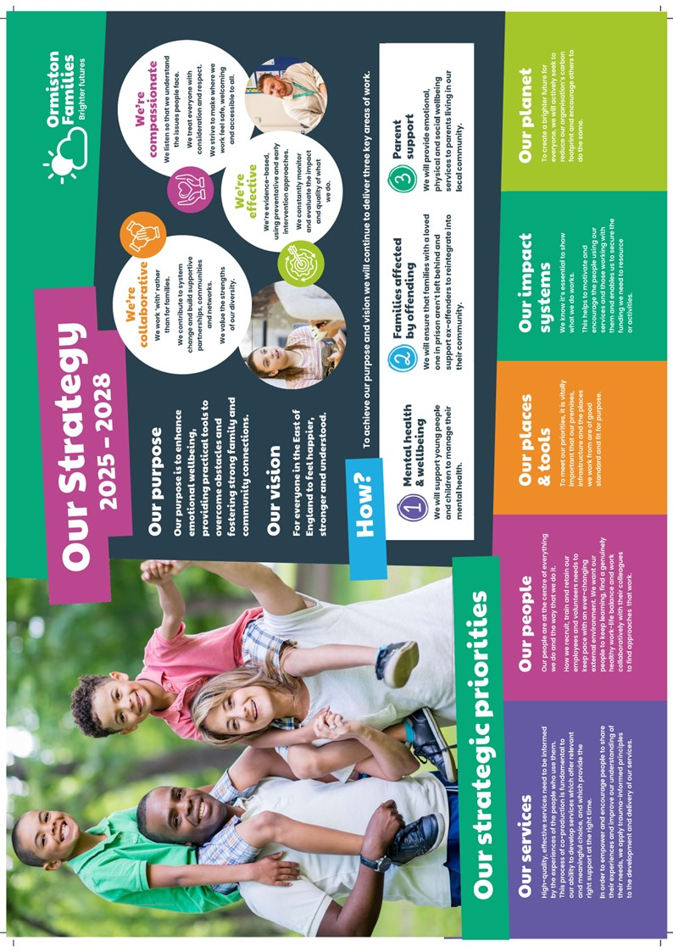
CHILDREN’S WELLBEING PRACTITIONER
(Full-Time & Part-Time)
YOUnited

A message from our Interim CEO, Mark Proctor

Dear Applicant,

Thank you for your interest in the post of Children’s Wellbeing Practitoiner in our YOUnited Service.

Over the last four years, the strategic plans we set in 2019 successfully guided us through a particularly challenging period around the world. Within this time, we have strengthened our infrastructure, said goodbye to some services and welcomed and substantially grown others. We have adopted a new brand identity, giving us a much fresher and more optimistic outlook. We have also invested in our most important asset, our staff, and begun to apply our values across every area of our work. In short, we are now a safer, healthier, and more resilient organisation which has enabled more children, young people, and families to feel safer, healthier, and more resilient too.

In June last year, we began the process of looking forward to set out a plan for the next three years. We looked at what had been working well and what more needs to be done to improve our quality and reach within the East of England. The enclosed strategic plan for 2022 – 25 is now well underway and we see the recruitment of this post as critical in helping us achieve our objectives.

I wish you the best of luck with your application.

Best regards,

Mark Proctor

Who Are Ormiston Families?

Ormiston Families is one of the leading charities working with children, young people, and families in the East of England. We take early and preventative action to support families to be safe, healthy, and resilient. All our services help people to build stronger networks, learn from experience and feel in control of their own wellbeing. We can only achieve this with the people who choose to work for us.

About YOUnited
YOUnited was set up in 2021 and is a partnership of Ormiston Families, Centre 33 and Cambridgeshire & Peterborough Foundation Trust. YOUnited provides a single point of access for all referrals for CYP in need of support with their mental health across Cambridgeshire and Peterborough. Ormiston Families work with CYP aged 5-13 with mild to moderate mental health and emotional wellbeing needs.
About the role
We currently are recruiting for the following permanent and temporary posts as Children’s Wellbeing Practitioner:
- Full Time – 35 hours per week
- Part Time - minimum of 21 hours
These positions offer a great opportunity for qualified counsellors to make valuable and lasting difference to the lives of children and young people aged 5-13.
We are committed to a ‘Single Sessions Thinking’ (SST) approach as this has proved to be very successful (Training will be provided). You will therefore provide a blend of first appointments using SST, alongside short-term therapeutic interventions. This will include face to face and online contacts, group and individual work.
You will join a supportive team where clinical supervision is provided.

About you
Successful candidates will:

- Be a qualified CWP or EMHP (or waiting confirmation of qualification)
- Registered with BACP or BABCP
- Have experience of delivering low intensity CBT-informed interventions, preferably to children and young people aged 5-13 and their carers.
- Be able to demonstrate a good understanding of the mental health presentations in children and young people in the age group
- Have a sound knowledge of guided self-help interventions.

Offices are in March, Cambridgeshire and King Fisher House, Huntingdon. Successful candidates will be expected to work from home and both offices, when required, with most face-to-face sessions being undertaken in schools. An ability to therefore travel across Cambridgeshire and Peterborough is essential.

When applying please can you confirm whether you are applying for full-time or part-time post. If part-time, please confirm how many hours per week.

Safer Recruitment

Application Process / Post Requirement
You must demonstrate that you meet the competencies; experience, knowledge, skills, and qualifications, that are required for this role (see Job Description below).
You must complete and submit an online application form (via the ‘Work with Us’ section of our website) detailing in the personal statement section, how you meet the criteria.

Rights to Work in the UK (RTW) (in person or remote)
The Recruiting Manager will need to see the original documents providing proof of your right to work in the UK.
- UK Passport / Full UK Birth Certificate / Drivers Licence / Utilities Bill
(proof of address)
- EUSS Permanent Status or Pre-Status Share Code
- Current EU/EAA/Swiss Citizen Passport
- EU/EAA/Swiss Citizen Visa
- Home Office Certificate
- If the interview is held in person, we will verify hard copy documents which you will need to bring with you to the interview.
- If the interview is held remotely, you will need to email copies of your RTW documents to the Recruiting Manager before the interview. At the remote interview [Teams, Skype, Zoom] you will need to have the original hard copy documents available so the relevant checks can be undertaken.

Safeguarding and DBS Requirements for Your Role
Ormiston Families is committed to safeguarding and promoting the welfare of children, young people and adults at risk and expects all staff and volunteers to share this commitment. DBS checks or police vetting will be required for relevant posts.

Disclosure and Barring Service (DBS) Checks:
- As this position meets the definition of regulated activity under the Protection of Freedom Act 2012, appointments to this post will be subject to an enhanced DBS check with barred list check.
- Employment can commence once the check has been satisfactorily completed.
- If you have a conviction on your DBS check, an assessment of the relevance and impact of the conviction in relation to the post will be done to determine if the job offer can be confirmed.
- It is a serious criminal offence to knowingly apply for posts when you have been barred from working with children/young people and/or vulnerable adults.
- Additional questions for roles working with children, young people, or vulnerable adults to be explored at interview.
- As this post involves working either with children and young people or vulnerable adults Warner or Safer Care motivational type questions may be asked during the interview process.
- These questions are asked to establish your suitability to work with vulnerable groups by understanding your attitude, behaviour, and responses to situations.
- The questions will relate to your inspiration for working with vulnerable groups, your ability to build relationships and your resilience when working with such groups and may also explore your attitude to the use of authority.
- If you feel you would find these questions about yourself difficult to respond to then you may wish to reflect upon your suitability for the post.

Disclosure
- Ormiston Families encourages all candidates called for interview to provide details of their criminal record at an early stage in the application process.
  - This information can be sent under separate, confidential cover to the Human Resources Team hr@ormistonfamilies.org.uk
  - Ormiston Families guarantees that this information will only be seen by those who need to see it as part of the recruitment process.
- Unless the nature of the position allows Ormiston Families to ask questions about your entire criminal record only questions about "unspent" convictions as defined in the Rehabilitation of Offenders Act 1974 will be asked.
- Ormiston Families will ensure that every subject of a DBS Disclosure is aware of the existence of the DBS Code of Practice and make a copy available on request.
- Ormiston Families undertakes to discuss any matter revealed in a Disclosure with the person seeking the position before withdrawing a conditional offer of employment.
- Having a criminal record will not necessarily bar you from working with Ormiston Families. This will depend on the nature of the position and the circumstances and background of the offences.

Qualification
- The Recruiting Manager will need to see the original copies of your qualification either in person or via video conference.
- If the interview is held in person, we will verify hard copy documents which you will need to bring with you to the interview.
- If the interview is held via video conference, you will need to email copies of your qualification to the Recruiting Manager before the interview. At the interview, you will need to have the original hard copy documents available so the relevant checks can be undertaken.
- If short-listed and you are required to hold a particular qualification for a post it is your responsibility to provide the relevant certification, to prove you are suitably qualified.
- Failure to produce documentary evidence of qualifications or undertake required courses/training may result in the termination of your employment.
- If a post requires you to take training or additional qualifications then, by accepting this post, you are agreeing to do the training or take the qualifications.

References
- If appointed, we will ask you for referee details which cover your past 3 years of employment, one of which must be your current/most recent employer.

Health Check
- If appointed and to ensure the post does not have a detrimental effect on your health or your health on your work, you will have to complete a health enquiry form, and may be required to have a medical via Occupational Health.
- This is to confirm that you are able to satisfactorily carry out the post without any impact on your health (taking account of any reasonable adjustments required).
- It will be separated from your application form and will not be seen by anyone involved in recruitment to this job.

GDPR / Data Protection:
- Ormiston Families is required by law to comply with the UK GDPR / Data Protection Act 2018.
- Employees have an important role to play in ensuring that personal information is processed lawfully and fairly.
- Personal information is information relating to a living individual who can be identified.
- It is each individual employee’s responsibility to handle all personal information properly no matter how it is collected, recorded, and used, whether on paper, in a computer, or on other material.
- Personal information must not be disclosed to others unless authorised to do so.
- All personal /sensitive information will be sent to you via Egress encryption service or password protected.

Equal Opportunities:
- Ormiston Families is an equal opportunities employer.
- We value diversity and welcome applications from all sections of the community.
- We ask you to complete a monitoring form to help us monitor the diversity of applicants. It will be separated from your application form and will not be seen by anyone involved in recruitment to this job.
- The gender identity, disability, marital status, ethnic origin, age, pregnancy status, religion or belief, or sexual orientation of an applicant or employee does not affect the employment opportunities made available, except as permitted by legislation.
- In addition, applicants declaring a disability who meet the minimum (essential) criteria for a vacancy will be invited for interview.
- Ormiston Families seeks to ensure that all employees are selected, trained, and promoted on the basis of ability, the requirements of the post and other similar and objective criteria.

Any queries, please email: ted.welsh@ormistonfamilies.org.uk

Ormiston Families reserves the right to close the vacancy early if we have received sufficient applications ahead of the closing date.

Information about working
for Ormiston Families

Job Title: Children’s Wellbeing Practitioner
Duration
The posts advertised are either permanent or temporary and full-time, with flexible or agile working.

Hours of Work and Working Arrangements:
- 35 hours per week but will consider applications for part time working with a minimum of 21 hours per week. (We anticipate this being 3 days x 7 hours).
- You will be required to work flexibly to meet the needs of the service which may include early evenings.

Location:
- Offices are in March, Cambridgeshire and King Fisher House, Huntingdon. Successful candidates will be expected to work from home and both offices, when required, with most face-to-face sessions being undertaken in schools. An ability to therefore travel across Cambridgeshire and Peterborough is essential.

Salary:
- The salary for this post is £228,2294 per annum, based on a 35 hour week.
- Salary is paid in 12 equal instalments on the 25th of each month directly into your bank account and covers work carried out in the calendar month.

Probationary Period:
- The post is subject to a probationary period of 6 months during which your progress will be monitored in accordance with agreed objectives.

Travelling Requirements for Your Role
- Ormiston Families positively encourages the use of technology to communicate and engage but in this role you will need to travel.
- You must either hold a full and current driving licence and have access to personal transport or meet the mobility requirements of the role through other reasonable and suitable means.
- Any mileage undertaken on behalf of Ormiston Families will be paid in accordance with our Expenses Policy and within Her Majesty’s Revenue and Customs guidelines.
- If you require a reasonable adjustment due to a disability to meet the travel requirements of this role, please speak with the contact detailed below.
- If you use your own vehicle for the purposes of work, you must ensure that your insurance policy covers you for this purpose.



Job Description

Job Title: Children’s Wellbeing Practitioners
Service: YOUnited
Location: Cambridgeshire and Peterborough

Job Purpose
To use a Single Session Thinking (SST) approach during all initial contacts and deliver the guided self-help intervention for CYP aged 5-13 and their carers, with mild to moderate mental health and emotional wellbeing needs, through a blended approach of online and face to face sessions.

Main Duties and Responsibilities
- To deliver an evidence-based guided self-help (GSH) interventions to children and young people Ormiston Families work with CYP aged 5-13 with mild to moderate mental health and emotional wellbeing needs.
- To undertake initial contacts using an SST approach to respond to presenting mental health concerns with children and parents/ caregivers to engage them in collaborative treatment planning. SST training will be provided.
- To plan and deliver deliver guided self-help groups, 1:1 sessions and workshops on the four themes within the GSH model (Parent led anxiety, adolescent anxiety, low mood and behaviour)
- To support and empower children, young people, and families to make informed choices about the intervention.
- To operate from an inclusive values base, which recognises and respects diversity.
- To undertake accurate assessment of risk to self and others, to collaboratively safety plan and document in a professional and clear manner, referring to other services where appropriate.
- To provide a range of information and support for evidence based psychological treatments, primarily guided self-help. This work may be face-to-face, by telephone or via other media.
- To attend multi-disciplinary meetings relating to referrals or CYP in treatment, where appropriate.
- To keep coherent records of all activity in line with service protocols and use these records and outcome data to inform decision making.
- To complete all requirements relating to ROMs and data collection.

Professional

- Ensure the maintenance of standards of practice according to the employer and any regulating bodies and keep up to date on new recommendations/guidelines set by the relevant departments.
- Ensure that confidentiality is always protected.
- Ensure clear objectives are identified, discussed and reviewed with supervisor and senior colleagues on a regular basis as part of continuing professional development.
- Participate in individual performance review and respond to agreed objectives.
- Attend relevant conferences/workshops in line with identified professional objectives.

Generic Duties
- To undertake any other reasonable duty, which is appropriate to the grade when requested by senior practitioners or managers.
- To be familiar with and comply with all Ormiston Families policies, procedures, protocols and guidelines.
- To demonstrate an understanding and commitment to the charity’s values.
- You may be required to conduct other tasks based on the business needs.

Personal Specification

Qualifications
Essential | Desirable
Post Graduate Qualification as a Children’s Wellbeing Practitioner or Education Mental Health Practitioner.
To be registered with a professional body or working towards registration -BACP or BABCP

Experience
Essential | Desirable
Relevant experience of working with children, young people aged 5-13 and their families. | Experience of working in mental health or related services
Experience of working collaboratively with service users and their families/carers | Worked in a service where agreed targets are in place to demonstrate outcomes
Experience of delivering 1:1 and group interventions via telephone, online and face to face

Abilities and Knowledge
Essential | Desirable
Knowledge and understanding of mental health presentations in children, young people and adults
Knowledge of, and ability to operate within, professional and ethical guidelines
Knowledge of development in children / young people and of family development and transitions
Knowledge of professional and legal issues relevant to working with children and young people
Ability to engage and communicate with children/young people of differing ages, developmental level and background
Ability to recognise and respond to concerns about child protection
Ability to work within and across agencies
Ability to work with, issues of confidentiality, consent and capacity
Ability to work with difference (‘cultural competence’)
Ability to identify when it is appropriate for self-help materials to be employed
Ability to manage endings and service transitions
Ability to make good use of supervision
Ability to use Microsoft Office applications
Ability to make use of measures, including monitoring or outcomes
A willingness and ability to travel independently across Cambridgeshire and Peterborough to meet the requirements of the post.

Professional and Personal Development
- All staff must ensure that they are aware of their responsibilities by attending mandatory training and our induction programme.
- All staff will have a formal appraisal with their manager at least every 12 months. Once performance/training objectives have been set, the staff member’s progress will be reviewed on a regular basis so that new objectives can be agreed and set, in order to maintain progress in the service delivery.
- All staff will be expected to take responsibility for their own professional development and will be supported to achieve development opportunities as appropriate.

Health and Safety
- All staff have a responsibility to maintain the health and safety of self and others within the performance of duties in accordance with health and safety policies, and to undertake specific health and safety responsibilities as directed. All staff have a responsibility to adhere to the risk management policies & procedures.
- All staff are required to contribute to the control of risk, and must report immediately any incident, accident or near miss involving service users, carers, staff, contractors, or members of the public.

Confidentiality and Information Governance
- All staff may gain or have access to confidential information about the assessment and/or treatment of service users, information affecting the public, private or work related staff information, or charity matters. A breach of confidentiality will have occurred where any such information has been divulged, passed (deliberately or accidentally) or overheard by any unauthorised person or person(s). Breaches of confidentiality can result in disciplinary action, which may involve dismissal.
- All staff must maintain a high standard of quality in corporate and clinical record keeping, ensuring information is always recorded accurately, appropriately and kept up to date. Staff must only access information, whether paper, electronic or in other media which is authorised to them as part of their duties.
- All staff must ensure compliance with the Data Protection Act 2018 and the UK GDPR.

Safeguarding: Adults and Children (Section 11 of the Children Act 2004)
- Every member of staff has a responsibility to be aware of and follow at all times, the relevant national and local policy in relation to safeguarding children and safeguarding adults.
- Safeguarding and DBS requirements for your role:
- Ormiston Families is committed to safeguarding and promoting the welfare of children, young people and adults at risk and expects all staff and volunteers to share this commitment. DBS checks or police vetting will be required for relevant posts.

Senior Managers
- Under Section 11 of the Children Act senior managers have responsibility for ensuring that service developments take into account the promotion of welfare and is informed by the views of children and families; providing training on safeguarding for all staff; recruiting safely; ensuring there is effective inter-agency working and information sharing.


Freedom of Information (FOI)
- All members of staff must be aware of their responsibilities under the Freedom of Information (FOI) Act 2000. The Act gives individuals or organisations the right to request information held by the charity. Staff must manage information they hold in such a way that meets the requirements of the Act. All requests for disclosures under the Act must be passed to the Privacy Officer.

Data Quality
- The Charity recognises the role of reliable information in the delivery & development of its services and in assuring robust clinical and corporate governance. Data quality is central to this, and the availability of complete, comprehensive, accurate and timely data is an essential component in the provision of high-quality mental health services. It is therefore the responsibility of all staff to ensure that where appropriate, information is recorded, at all times, in line with the charity’s policy and procedures for data quality.
- This job description seeks to provide an outline of the duties and responsibilities of the post. It is not a definitive document and does not form part of the main statement of terms and conditions. The job description will be reviewed as part of the annual appraisal process and will be used as the basis for setting objectives.

Benefits & Recognition
All benefits are discretionary, and Ormiston Families reserves the right to change or amend benefits at any given time.
Cycle to Work
- Cycle to Work allows you to order a new bike, equipment or both up to the value of £1,000 which you can pay back through your salary to make tax savings.

Annual Leave Entitlement:
- The basic annual leave entitlement is 27 days plus additional leave for employees who have completed 1 years’ service up to a maximum of 30 days
- Part-time employees receive a pro-rata allowance according to the number of hours they work per week.
- Ability to buy and sell up to 5 days’ annual leave within any leave year. (All leave must be taken within the year it is purchased including any agreed leave brought forward from the previous year.)

Group Life Assurance:
- Ormiston Families provides a death in service benefit to up to the age of 70, that includes and covers permanent, fixed-term and as & when contracted employees.
Occupational Sick Pay Scheme:
- Ormiston Families operates an occupational sick pay scheme in addition to statutory sick pay.

Pension:
- Ormiston Families provides a Group Personal Pension Scheme with up to 9% of gross salary employer contribution for any employee where they match the level of contribution.

Sponsorship:
- Ormiston Families provides the opportunity to apply for sponsorship to employees who have completed their probationary period and been in post for at least 12 months to undertake nationally accredited or chartered certification awarded by professional associations.
Employee Assistance Programme:
- Ormiston Families provides a comprehensive employee assistance programme which offers free and confidential access to telephone and unlimited video counselling sessions, financial and legal advice, and assistance in finding information about a wide range of subjects from childcare to moving to a new house.

Employee Discount Scheme:
- The Hive is a savings platform which can be accessed by employees to make everyday purchases at reduced costs. Employees can save money by purchasing reloadable cards, obtain cashback through online purchases, and make savings in many stores.

Your Wellbeing:
- We have trained Mental Health First Aiders who form our Wellbeing Team, promoting mental and physical health. Ormiston Families has also signed the pledge to support our employees going through the menopause in the workplace.

The Wellbeing Centre:
- Accessed via The Hive, the Wellbeing Centre provides education, support and tools to help you live a healthier and happier life.

Pets in the Workplace:
- We are a dog-friendly employer, which means that from time to time we allow colleagues to bring their pets into our workplaces. If you would like a copy of our Pets in the Workplace policy or would like to discuss this in more detail, please contact our HR team.


We build supportive partnerships, communities, and networks

