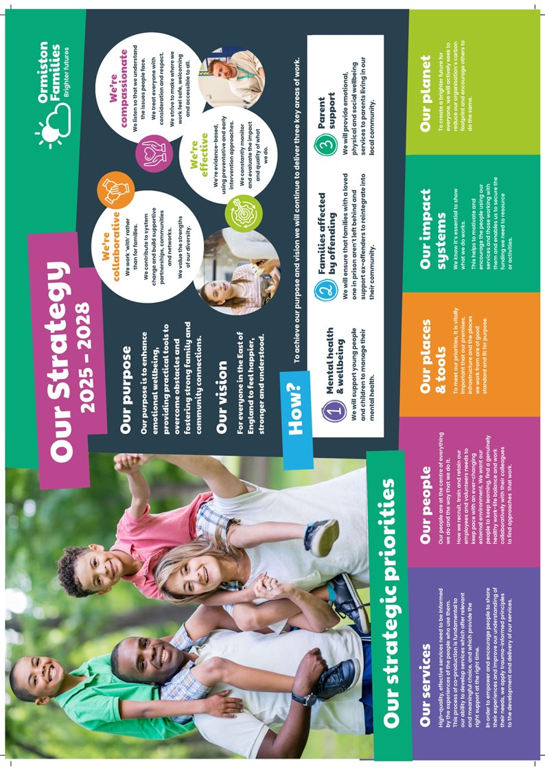
Who Are Ormiston Families?
Marketing & Supporter Engagement Officer
Income Generation

Ormiston Families is one of the leading charities working with children, young people, and families in the East of England. We take early and preventative action to support families to be safe, healthy, and resilient. All our services help people to build stronger networks, learn from experience and feel in control of their own wellbeing. We can only achieve this with the people who choose to work for us.

About Income Generation
The Income Generation team plays a vital role in securing the funding needed for Ormiston Families to run its services.
The team looks after fundraising for the charity, including trusts, events and community fundraising. It also looks after our Communications and Marketing.
About the role
Sitting within the Communications and Marketing team, the Marketing and Supporter Engagement Officer is the welcoming face of the charity, helping supporters to engage with our work and get the most out of their relationship with Ormiston Families. They are also responsible for marketing, in order to reach potential new supporters.

About you
You will be someone passionate about building powerful relationships with an understanding of how our messaging and storytelling can connect with existing and potential supporters. The job holder must have a strong understanding of what motivates people to support Ormiston Families and how to attract them to our cause.
Safer Recruitment

Application Process / Post Requirement
You must demonstrate that you meet the competencies; experience, knowledge, skills, and qualifications, that are required for this role (see Job Description below).
You must complete and submit an online application form (via the ‘Work with Us’ section of our website) detailing in the personal statement section, how you meet the criteria.

Rights to Work in the UK (RTW) (in person or remote)
The Recruiting Manager will need to see the original documents providing proof of your right to work in the UK.
- UK Passport / Full UK Birth Certificate / Drivers Licence / Utilities Bill
(proof of address)
- EUSS Permanent Status or Pre-Status Share Code
- Current EU/EAA/Swiss Citizen Passport
- EU/EAA/Swiss Citizen Visa
- Home Office Certificate
- If the interview is held in person, we will verify hard copy documents which you will need to bring with you to the interview.
- If the interview is held remotely, you will need to email copies of your RTW documents to the Recruiting Manager before the interview. At the remote interview [Teams, Skype, Zoom] you will need to have the original hard copy documents available so the relevant checks can be undertaken.

Safeguarding and DBS Requirements for Your Role
Ormiston Families is committed to safeguarding and promoting the welfare of children, young people and adults at risk and expects all staff and volunteers to share this commitment. DBS checks or police vetting will be required for relevant posts.

Disclosure
- Ormiston Families encourages all candidates called for interview to provide details of their criminal record at an early stage in the application process.
  - This information can be sent under separate, confidential cover to the Human Resources Team hr@ormistonfamilies.org.uk
  - Ormiston Families guarantees that this information will only be seen by those who need to see it as part of the recruitment process.
- Unless the nature of the position allows Ormiston Families to ask questions about your entire criminal record only questions about "unspent" convictions as defined in the Rehabilitation of Offenders Act 1974 will be asked.
- Ormiston Families will ensure that every subject of a DBS Disclosure is aware of the existence of the DBS Code of Practice and make a copy available on request.
- Ormiston Families undertakes to discuss any matter revealed in a Disclosure with the person seeking the position before withdrawing a conditional offer of employment.
- Having a criminal record will not necessarily bar you from working with Ormiston Families. This will depend on the nature of the position and the circumstances and background of the offences.

Qualification
- The Recruiting Manager will need to see the original copies of your qualification either in person or via video conference.
- If the interview is held in person, we will verify hard copy documents which you will need to bring with you to the interview.
- If the interview is held via video conference, you will need to email copies of your qualification to the Recruiting Manager before the interview. At the interview, you will need to have the original hard copy documents available so the relevant checks can be undertaken.
- If short-listed and you are required to hold a particular qualification for a post it is your responsibility to provide the relevant certification, to prove you are suitably qualified.
- Failure to produce documentary evidence of qualifications or undertake required courses/training may result in the termination of your employment.
- If a post requires you to take training or additional qualifications then, by accepting this post, you are agreeing to do the training or take the qualifications.

References
- If appointed, we will ask you for referee details which cover your past 3 years of employment, one of which must be your current/most recent employer.

Health Check
- If appointed and to ensure the post does not have a detrimental effect on your health or your health on your work, you will have to complete a health enquiry form, and may be required to have a medical via Occupational Health.
- This is to confirm that you are able to satisfactorily carry out the post without any impact on your health (taking account of any reasonable adjustments required).
- It will be separated from your application form and will not be seen by anyone involved in recruitment to this job.

GDPR / Data Protection:
- Ormiston Families is required by law to comply with the UK GDPR / Data Protection Act 2018.
- Employees have an important role to play in ensuring that personal information is processed lawfully and fairly.
- Personal information is information relating to a living individual who can be identified.
- It is each individual employee’s responsibility to handle all personal information properly no matter how it is collected, recorded, and used, whether on paper, in a computer, or on other material.
- Personal information must not be disclosed to others unless authorised to do so.
- All personal /sensitive information will be sent to you via Egress encryption service or password protected.

Equal Opportunities:
- Ormiston Families is an equal opportunities employer.
- We value diversity and welcome applications from all sections of the community.
- We ask you to complete a monitoring form to help us monitor the diversity of applicants. It will be separated from your application form and will not be seen by anyone involved in recruitment to this job.
- The gender identity, disability, marital status, ethnic origin, age, pregnancy status, religion or belief, or sexual orientation of an applicant or employee does not affect the employment opportunities made available, except as permitted by legislation.
- In addition, applicants declaring a disability who meet the minimum (essential) criteria for a vacancy will be invited for interview.
- Ormiston Families seeks to ensure that all employees are selected, trained, and promoted on the basis of ability, the requirements of the post and other similar and objective criteria.

Any queries, please email: Andrew.fitchett@ormistonfamilies.org.uk

Ormiston Families reserves the right to close the vacancy early if we have received sufficient applications ahead of the closing date.

Information about working
for Ormiston Families

Job Title: Marketing & Supporter Engagement Officer

Duration
The post advertised is permanent, with flexible or agile working.

Hours of Work and Working Arrangements:
- The normal working week is 35 hours, Monday to Friday and covers 52 weeks per year.
- You will be required to work flexibly to meet the needs of the service which may include evenings and weekends.

Location:
- Your base will be hybrid.

Salary:
- The salary for this post is £32,953 per annum, based on 35 hours per week.
- Salary is paid in 12 equal instalments on the 25th of each month directly into your bank account and covers work carried out in the calendar month.

Probationary Period:
- The post is subject to a probationary period of 6 months during which your progress will be monitored in accordance with agreed objectives.

Travelling Requirements for Your Role
- Ormiston Families positively encourages the use of technology to communicate and engage but in this role you may need to travel.
- You must either hold a full and current driving licence and have access to personal transport or meet the mobility requirements of the role through other reasonable and suitable means.
- Any mileage undertaken on behalf of Ormiston Families will be paid in accordance with our Expenses Policy and within Her Majesty’s Revenue and Customs guidelines.
- If you require a reasonable adjustment due to a disability to meet the travel requirements of this role, please speak with the contact detailed below.
- If you use your own vehicle for the purposes of work, you must ensure that your insurance policy covers you for this purpose.



Job Description

Job Title: Marketing & Supporter Engagement Officer
Service: Income Generation
Location: Hybrid
Reporting To: Head of Communications and Public Affairs

Job Purpose
The post holder will support the Income Generation Team in driving supporter engagement and donations through marketing and communications campaigns. They will manage stewardship programmes, develop multi-channel campaigns, and ensure supporters feel connected to Ormiston Families' mission.

Main Duties and Responsibilities
- Develop and manage multi-channel campaigns to create new supporter connections.
- Implement the supporter journey strategy by creating high-quality marketing content that aligns with objectives and targets specific audiences.
- Manage supporter relationships and ensure effective engagement.
- Maintain and oversee the supporter database to record communications and track supporter details.
- Collaborate with the wider Income Generation team to develop and execute appeals and events.
- Manage targeted social media advertising campaigns and related budgets.
- Work with the Communications and Engagement Officer to produce targeted content and a publication schedule.
- Work within Ormiston Families’ mission and values, adhering to all policies and procedures, including Safeguarding, Equality and Diversity, Participation, Quality, and Health and Safety.
- Comply with relevant external standards and Quality Marks.
- Undertake any additional duties as instructed by the manager.

General Duties
- Liaise with staff across the charity to stay informed about our services and their impact.
- Work with colleagues in our Data and Insight to team to ensure access to the latest data.
- Stay up to date with latest developments in fundraising and marketing to ensure best practice.
- Undertake training courses – both in-house and external – when necessary to keep skills up to date.
- Undertake service visits on a schedule agreed with the Head of Communications and Marketing.

Personal Specification
Qualifications
Essential | Desirable
Relevant degree or qualification

Experience
Essential | Desirable
Relevant experience in supporting and delivering multi-channel marketing communications or fundraising campaigns. | Copywriting experience
Experience in individual fundraising.
Experience in developing and managing supporter relationships.
Experience in tracking, analysing, and using data.
Experience in using a CRM (e.g., Salesforce, Raiser’s Edge) and confidence using data to drive decision-making.

Abilities and Knowledge

Essential | Desirable
Ability to use data to drive decision-making | Knowledge of various social media platforms and their advertising tools (especially LinkedIn, Instagram, and Facebook)
Excellent written and verbal communication skills | Strong interpersonal skills and experience building relationships with team members and stakeholders.
Strong analytical skills to understand, analyse, and interpret results to optimise campaigns. | Agile and creative thinker with the ability to self-manage, innovate, and respond creatively to challenges
Ability to work flexibly and independently, managing varying competing priorities and meeting deadlines. | Awareness of data protection regulations, particularly PECR (Privacy and Electronic Communications Regulations)
Openness to collaboration. | Strong IT skills
Attention to detail.

Professional and Personal Development
- All staff must ensure that they are aware of their responsibilities by attending mandatory training and our induction programme.
- All staff will have a formal appraisal with their manager at least every 12 months. Once performance/training objectives have been set, the staff member’s progress will be reviewed on a regular basis so that new objectives can be agreed and set, in order to maintain progress in the service delivery.
- All staff will be expected to take responsibility for their own professional development and will be supported to achieve development opportunities as appropriate.

Health and Safety
- All staff have a responsibility to maintain the health and safety of self and others within the performance of duties in accordance with health and safety policies, and to undertake specific health and safety responsibilities as directed. All staff have a responsibility to adhere to the risk management policies & procedures.
- All staff are required to contribute to the control of risk, and must report immediately any incident, accident or near miss involving service users, carers, staff, contractors, or members of the public.

Confidentiality and Information Governance
- All staff may gain or have access to confidential information about the assessment and/or treatment of service users, information affecting the public, private or work related staff information, or charity matters. A breach of confidentiality will have occurred where any such information has been divulged, passed (deliberately or accidentally) or overheard by any unauthorised person or person(s). Breaches of confidentiality can result in disciplinary action, which may involve dismissal.
- All staff must maintain a high standard of quality in corporate and clinical record keeping, ensuring information is always recorded accurately, appropriately and kept up to date. Staff must only access information, whether paper, electronic or in other media which is authorised to them as part of their duties.
- All staff must ensure compliance with the Data Protection Act 2018 and the UK GDPR.

Safeguarding: Adults and Children (Section 11 of the Children Act 2004)
- Every member of staff has a responsibility to be aware of and follow at all times, the relevant national and local policy in relation to safeguarding children and safeguarding adults.
- Safeguarding and DBS requirements for your role:
- Ormiston Families is committed to safeguarding and promoting the welfare of children, young people and adults at risk and expects all staff and volunteers to share this commitment. DBS checks or police vetting will be required for relevant posts.

Senior Managers
- Under Section 11 of the Children Act senior managers have responsibility for ensuring that service developments take into account the promotion of welfare and is informed by the views of children and families; providing training on safeguarding for all staff; recruiting safely; ensuring there is effective inter-agency working and information sharing.


Freedom of Information (FOI)
- All members of staff must be aware of their responsibilities under the Freedom of Information (FOI) Act 2000. The Act gives individuals or organisations the right to request information held by the charity. Staff must manage information they hold in such a way that meets the requirements of the Act. All requests for disclosures under the Act must be passed to the Privacy Officer.

Data Quality
- The Charity recognises the role of reliable information in the delivery & development of its services and in assuring robust clinical and corporate governance. Data quality is central to this, and the availability of complete, comprehensive, accurate and timely data is an essential component in the provision of high-quality mental health services. It is therefore the responsibility of all staff to ensure that where appropriate, information is recorded, at all times, in line with the charity’s policy and procedures for data quality.
- This job description seeks to provide an outline of the duties and responsibilities of the post. It is not a definitive document and does not form part of the main statement of terms and conditions. The job description will be reviewed as part of the annual appraisal process and will be used as the basis for setting objectives.

Benefits & Recognition
All benefits are discretionary, and Ormiston Families reserves the right to change or amend benefits at any given time.
Cycle to Work
- Cycle to Work allows you to order a new bike, equipment or both up to the value of £1,000 which you can pay back through your salary to make tax savings.

Annual Leave Entitlement:
- The basic annual leave entitlement is 27 days plus additional leave for employees who have completed 1 years’ service up to a maximum of 30 days
- Part-time employees receive a pro-rata allowance according to the number of hours they work per week.
- Ability to buy and sell up to 5 days’ annual leave within any leave year. (All leave must be taken within the year it is purchased including any agreed leave brought forward from the previous year.)

Group Life Assurance:
- Ormiston Families provides a death in service benefit to up to the age of 70, that includes and covers permanent, fixed-term and as & when contracted employees.
Occupational Sick Pay Scheme:
- Ormiston Families operates an occupational sick pay scheme in addition to statutory sick pay.

Pension:
- Ormiston Families provides a Group Personal Pension Scheme with up to 9% of gross salary employer contribution for any employee where they match the level of contribution.

Sponsorship:
- Ormiston Families provides the opportunity to apply for sponsorship to employees who have completed their probationary period and been in post for at least 12 months to undertake nationally accredited or chartered certification awarded by professional associations.
Employee Assistance Programme:
- Ormiston Families provides a comprehensive employee assistance programme which offers free and confidential access to telephone and unlimited video counselling sessions, financial and legal advice, and assistance in finding information about a wide range of subjects from childcare to moving to a new house.

Employee Discount Scheme:
- The Hive is a savings platform which can be accessed by employees to make everyday purchases at reduced costs. Employees can save money by purchasing reloadable cards, obtain cashback through online purchases, and make savings in many stores.

Your Wellbeing:
- We have trained Mental Health First Aiders who form our Wellbeing Team, promoting mental and physical health. Ormiston Families has also signed the pledge to support our employees going through the menopause in the workplace.

The Wellbeing Centre:
- Accessed via The Hive, the Wellbeing Centre provides education, support and tools to help you live a healthier and happier life.

Pets in the Workplace:
- We are a dog-friendly employer, which means that from time to time we allow colleagues to bring their pets into our workplaces. If you would like a copy of our Pets in the Workplace policy or would like to discuss this in more detail, please contact our HR team.


We build supportive partnerships, communities, and networks

