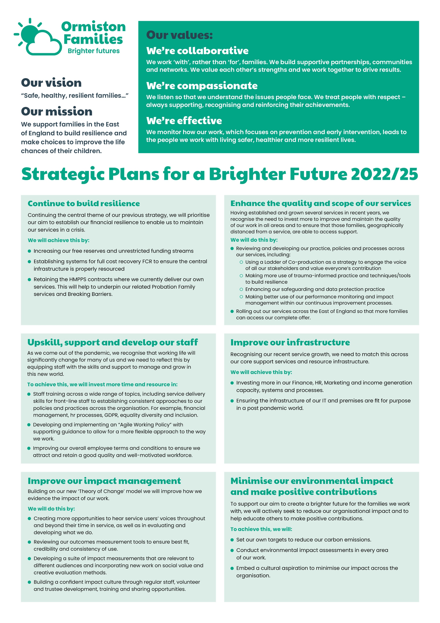
Therapeutic Practitioner
Supporting Smiles
A message from our CEO, Allan Myatt

Dear Applicant,

Thank you for your interest in the post of Therapeutic Practitioner with our Supporting Smiles service.

Over the last four years, the strategic plans we set in 2019 successfully guided us through a particularly challenging period around the world. Within this time, we have strengthened our infrastructure, said goodbye to some services and welcomed and substantially grown others. We have adopted a new brand identity, giving us a much fresher and more optimistic outlook. We have also invested in our most important asset, our staff, and begun to apply our values across every area of our work. In short, we are now a safer, healthier, and more resilient organisation which has enabled more children, young people, and families to feel safer, healthier, and more resilient too.

In June last year, we began the process of looking forward to set out a plan for the next three years. We looked at what had been working well and what more needs to be done to improve our quality and reach within the East of England. The enclosed strategic plan for 2022 – 25 is now well underway and we see the recruitment of this post as critical in helping us achieve our objectives.

I wish you the best of luck with your application.

Best regards,

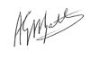
Allan Myatt

Who Are Ormiston Families?

Ormiston Families is one of the leading charities working with children, young people and families in the East of England. We take early and preventative action to support families to be safe, healthy and resilient. All our services help people to build stronger networks, learn from experience and feel in control of their own wellbeing. We can only achieve this with the people who choose to work for us.

About Our Service
Our Supporting Smiles service provides professional mental health support to children and young people through our Therapeutic Pathway for 4–13-year-olds and 5–18-year-olds with our Children’s Wellbeing Practitioner team. Whether residing in Norfolk or Waveney or registered with a Norfolk or Waveney GP, we're here to offer therapeutic support to meet children and young people’s needs.

At Supporting Smiles, we believe in a needs-led approach, and our service name, "Supporting Smiles," was co-created with input from the children and families we support. Our holistic mental health and wellbeing support service encompasses the expertise of our therapeutic practitioners, counsellors, and children’s wellbeing practitioners, complemented by therapeutic support from our partners at The Benjamin Foundation. Together, we are committed to working alongside a network of support that extends beyond our walls and into the heart of the community.

About the role

Our therapeutic support brilliantly extends into a successful training offer across Norfolk and Waveney through our Link Team, who are committed to further developing a well-established group of mental health champions.
Convenience and accessibility are key to our therapeutic support. We offer sessions in various venues across your local community, including schools and family hub sites. If accessing our venues poses a challenge, don't hesitate to reach out, and we'll work together to find a solution that suits your needs.
As a member of Norfolk & Waveney’s Children and Young People’s Alliance, we're part of an integrated mental health service network dedicated to THRIVE principles: Getting Advice, Getting Help, Getting More Help, and Risk Support. Alongside partners like The Benjamin Foundation, Norfolk & Suffolk NHS Foundation Trust, Norfolk County Council, and Cambridgeshire Community Services NHS Trust, we're committed to providing comprehensive support to children and young people aged 0-25, ensuring their mental health needs are met every step of the way.
About you

As the post holder you will hold a passion for excellence in your clinical role and have experience of working with young people presenting with a range of mental health difficulties and challenging behaviour. You will have previous experience of working therapeutically with children, young people and/or families and, ideally, wider experience of supporting young people and families.

The post-holder will provide high level professional therapeutic practice using appropriate interventions which are outcome focussed and evidence based. You will assess each referred child and young person as appropriate and liaise with the wider service regarding their needs, as well as carry out Routine Outcome Measures or other outcome and feedback measures at the appropriate points of the intervention as advised by the service

The successful candidates will join the service at an exciting time of development and will bring with them a passion to support the development of our therapeutic support to young people and families across Norfolk and Waveney.

This post is full time, 37.5 hours per week, with a starting salary of £33,706 per annum.

Safer Recruitment

Application Process / Post Requirement
You must demonstrate that you meet the competencies; experience, knowledge, skills, and qualifications, that are required for this role (see Job Description below).
You must complete and submit an online application form (via the ‘Work with Us’ section of our website) detailing in the personal statement section, how you meet the criteria.

Rights to Work in the UK (RTW) (in person or remote)
The Recruiting Manager will need to see the original documents providing proof of your right to work in the UK.
- UK Passport / Full UK Birth Certificate / Drivers Licence / Utilities Bill
(proof of address)
- EUSS Permanent Status or Pre-Status Share Code
- Current EU/EAA/Swiss Citizen Passport
- EU/EAA/Swiss Citizen Visa
- Home Office Certificate
- If the interview is held in person, we will verify hard copy documents which you will need to bring with you to the interview.
- If the interview is held remotely, you will need to email copies of your RTW documents to the Recruiting Manager before the interview. At the remote interview [Teams, Skype, Zoom] you will need to have the original hard copy documents available so the relevant checks can be undertaken.

Safeguarding and DBS Requirements for Your Role
Ormiston Families is committed to safeguarding and promoting the welfare of children, young people and adults at risk and expects all staff and volunteers to share this commitment. DBS checks or police vetting will be required for relevant posts.

Disclosure and Barring Service (DBS) Checks:
As this position meets the definition of regulated activity under the Protection of Freedom Act 2012, appointments to this post will be subject to an enhanced DBS check with barred list check.
- Employment can commence once the check has been satisfactorily completed.
- If you have a conviction on your DBS check, an assessment of the relevance and impact of the conviction in relation to the post will be done to determine if the job offer can be confirmed.
- It is a serious criminal offence to knowingly apply for posts when you have been barred from working with children/young people and/or vulnerable adults.
- Additional questions for roles working with children, young people, or vulnerable adults to be explored at interview.
- As this post involves working either with children and young people or vulnerable adults Warner or Safer Care motivational type questions may be asked during the interview process.
- These questions are asked to establish your suitability to work with vulnerable groups by understanding your attitude, behaviour, and responses to situations.
- The questions will relate to your inspiration for working with vulnerable groups, your ability to build relationships and your resilience when working with such groups and may also explore your attitude to the use of authority.
- If you feel you would find these questions about yourself difficult to respond to then you may wish to reflect upon your suitability for the post.

Disclosure
- Ormiston Families encourages all candidates called for interview to provide details of their criminal record at an early stage in the application process.
  - This information can be sent under separate, confidential cover to the Human Resources Team hr@ormistonfamilies.org.uk
  - Ormiston Families guarantees that this information will only be seen by those who need to see it as part of the recruitment process.
- Unless the nature of the position allows Ormiston Families to ask questions about your entire criminal record only questions about "unspent" convictions as defined in the Rehabilitation of Offenders Act 1974 will be asked.
- Ormiston Families will ensure that every subject of a DBS Disclosure is aware of the existence of the DBS Code of Practice and make a copy available on request.
- Ormiston Families undertakes to discuss any matter revealed in a Disclosure with the person seeking the position before withdrawing a conditional offer of employment.
- Having a criminal record will not necessarily bar you from working with Ormiston Families. This will depend on the nature of the position and the circumstances and background of the offences.

Qualification
- The Recruiting Manager will need to see the original copies of your qualification either in person or via video conference.
- If the interview is held in person, we will verify hard copy documents which you will need to bring with you to the interview.
- If the interview is held via video conference, you will need to email copies of your qualification to the Recruiting Manager before the interview. At the interview, you will need to have the original hard copy documents available so the relevant checks can be undertaken.
- If short-listed and you are required to hold a particular qualification for a post it is your responsibility to provide the relevant certification, to prove you are suitably qualified.
- Failure to produce documentary evidence of qualifications or undertake required courses/training may result in the termination of your employment.
- If a post requires you to take training or additional qualifications then, by accepting this post, you are agreeing to do the training or take the qualifications.

References
- If appointed, we will ask you for referee details which cover your past 3 years of employment, one of which must be your current/most recent employer.

Health Check
- If appointed and to ensure the post does not have a detrimental effect on your health or your health on your work, you will have to complete a health enquiry form, and may be required to have a medical via Occupational Health.
- This is to confirm that you are able to satisfactorily carry out the post without any impact on your health (taking account of any reasonable adjustments required).
- It will be separated from your application form and will not be seen by anyone involved in recruitment to this job.

GDPR / Data Protection:
- Ormiston Families is required by law to comply with the UK GDPR / Data Protection Act 2018.
- Employees have an important role to play in ensuring that personal information is processed lawfully and fairly.
- Personal information is information relating to a living individual who can be identified.
- It is each individual employee’s responsibility to handle all personal information properly no matter how it is collected, recorded and used, whether on paper, in a computer, or on other material.
- Personal information must not be disclosed to others unless authorised to do so.
- All personal /sensitive information will be sent to you via Egress encryption service or password protected.

Equal Opportunities:
- Ormiston Families is an equal opportunities employer.
- We value diversity and welcome applications from all sections of the community.
- We ask you to complete a monitoring form to help us monitor the diversity of applicants. It will be separated from your application form and will not be seen by anyone involved in recruitment to this job.
- The gender identity, disability, marital status, ethnic origin, age, pregnancy status, religion or belief, or sexual orientation of an applicant or employee does not affect the employment opportunities made available, except as permitted by legislation.
- In addition, applicants declaring a disability who meet the minimum (essential) criteria for a vacancy will be invited for interview.
- Ormiston Families seeks to ensure that all employees are selected, trained, and promoted on the basis of ability, the requirements of the post and other similar and objective criteria.

Any queries, please email: Brittanie.collins@ormistonfamilies.org.uk

Ormiston Families reserves the right to close the vacancy early if we have received sufficient applications ahead of the closing date.

Information about working
for Ormiston Families

Job Title: Therapeutic Practitioner

Duration
The post advertised is a full-time, permanent position.

Hours of Work and Working Arrangements:
- The normal working week is 37.5 hours, Monday to Friday and covers 52 weeks per year.
- You will be required to work flexibly to meet the needs of the service which may include evenings and weekends.

Location:
- Your base will be our Norwich Hub with a blend of remote working and working within the community across Norfolk & Waveney.

Salary:
- The starting salary for this post is £33,706 per annum, based on 37.5 hours per week.
- Salary is paid in 12 equal instalments on the 25th of each month directly into your bank account and covers work carried out in the calendar month.

Probationary Period:
- The post is subject to a probationary period of 6 months during which your progress will be monitored in accordance with agreed objectives.

Travelling Requirements for Your Role
- Ormiston Families positively encourages the use of technology to communicate and engage but in this role you will need to travel.
- You must either hold a full and current driving licence and have access to personal transport or meet the mobility requirements of the role through other reasonable and suitable means.
- Any mileage undertaken on behalf of Ormiston Families will be paid in accordance with our Expenses Policy and within Her Majesty’s Revenue and Customs guidelines.
- If you require a reasonable adjustment due to a disability to meet the travel requirements of this role, please speak with the contact detailed below.
- If you use your own vehicle for the purposes of work, you must ensure that your insurance policy covers you for this purpose.

Job Description

Job Title: Therapeutic Practitioner
Service: Supporting Smiles
Location: Norfolk & Waveney

Job Purpose
Ormiston Families’ Supporting Smiles Children and Young People’s Mental Health Service is excited to invite applications from therapists, looking to further their therapeutic career. We offer great benefits.

Our Supporting Smiles service provides professional mental health support to children and young people through our Therapeutic Pathway for 4–13-year-olds and 5–18-year-olds with our Children’s Wellbeing Practitioner team. Whether residing in Norfolk or Waveney or registered with a Norfolk or Waveney GP, we're here to offer therapeutic support to meet children and young people’s needs.

At Supporting Smiles, we believe in a needs-led approach, and our service name, "Supporting Smiles," was co-created with input from the children and families we support. Our holistic mental health and wellbeing support service encompasses the expertise of our therapeutic practitioners, counsellors, and children’s wellbeing practitioners, complemented by therapeutic support from our partners at The Benjamin Foundation. Together, we are committed to working alongside a network of support that extends beyond our walls and into the heart of the community.

Our therapeutic support brilliantly extends into a successful training offer across Norfolk and Waveney through our Link Team, who are committed to further developing a well-established group of mental health champions.

Convenience and accessibility are key to our therapeutic support. We offer sessions in various venues across your local community, including schools and family hub sites. If accessing our venues poses a challenge, don't hesitate to reach out, and we'll work together to find a solution that suits your needs.

As a member of Norfolk & Waveney’s Children and Young People’s Alliance, we're part of an integrated mental health service network dedicated to THRIVE principles: Getting Advice, Getting Help, Getting More Help, and Risk Support. Alongside partners like The Benjamin Foundation, Norfolk & Suffolk NHS Foundation Trust, Norfolk County Council, and Cambridgeshire Community Services NHS Trust, we're committed to providing comprehensive support to children and young people aged 0-25, ensuring their mental health needs are met every step of the way.

Main Duties and Responsibilities
• Assess each referred child and young person as appropriate and liaise with the wider service regarding their needs
• Carry out Routine Outcome Measures or other outcome and feedback measures at the appropriate points of the intervention as advised by the service
• Provide the appropriate number of therapeutic sessions based on the service provision and young person’s needs
• Deliver a single session approach where appropriate
• Provide high level professional therapeutic practice using appropriate interventions which are outcome focussed and evidence based
• To ensure comprehensive written records are kept of sessions, assessments, planning, progress and decision making
• Appropriately identify and transition referrals between relevant programmes/other services as necessary
• Pro-actively encourage service user involvement and feedback to monitor the quality and impact of our interventions and inform ongoing service improvements
• Complete paperwork as required to show progress made and impact of provision
• Promote other Ormiston Families services where appropriate

Generic Responsibilities

- Maintain levels of confidentiality within the limitations of the Safeguarding Policy
- Report safeguarding concerns to the Designated Safeguarding Lead in line with Ormiston Families’ safeguarding policies

Generic Duties
- To undertake any other reasonable duty, which is appropriate to the grade when requested by senior staff.
- To be familiar with and comply with all Ormiston Families policies, procedures, protocols and guidelines.
- To demonstrate an understanding and commitment to the charity’s values.
- You may be required to conduct other tasks based on the business needs.

Benefits include:

- Continued professional development training opportunities
- Management support and induction
- Access to peer support
- Access to appropriate clinical supervision

Personal Specification

Qualifications
Essential | Desirable
Relevant Professional Qualification, e.g.Play therapist, Systemic Family Practitioner, Drama therapist,, Psychotherapist, art , CBT therapist, IPT-A Therapist. | Supplementary clinical qualifications (EMDR, ACT, CAT DBT)
Current registration or accreditation with relevant professional body, such as UKCP, BACP, HCPC, PTUK, IPT, IPTUK, AFT | Qualified clinical supervisor

Experience
Essential | Desirable
At least 1 year’s previous experience of working therapeutically with children, young people and/or families | Worked in MDT settings/education settings/mental health service settings
Have obtained a minimum of 120 hours of clinical experience, and with a clinical supervisor | Experience working across a range of therapeutic modalities
Experience of undertaking assessment, formulation, risk assessment and safety planning
Demonstrate a commitment to continued CPD

Abilities and Knowledge
Essential | Desirable
Ability to establish and maintain clear boundaries in respect of personal and professional responsibility.
Demonstrate a thorough knowledge, understanding and use of evidence based therapeutic interventions.
Ability to work autonomously and make decisions to work as part of a team.
Awareness of safe-guarding procedures for children and young people and vulnerable adults.
Ability to follow Policies and Procedures in relation to Data Protection and Security, and Protection of Personal and Sensitive Personal data.
Ability to keep accurate records including service user development logs and use recorded data for evaluation and monitoring.
Be able to travel as required for the role (driving license and own car preferred).

Professional and Personal Development
- All staff must ensure that they are aware of their responsibilities by attending mandatory training and our induction programme.
- All staff will have a formal appraisal with their manager at least every 12 months. Once performance/training objectives have been set, the staff member’s progress will be reviewed on a regular basis so that new objectives can be agreed and set, in order to maintain progress in the service delivery.
- All staff will be expected to take responsibility for their own professional development and will be supported to achieve development opportunities as appropriate.

Health and Safety
- All staff have a responsibility to maintain the health and safety of self and others within the performance of duties in accordance with health and safety policies, and to undertake specific health and safety responsibilities as directed. All staff have a responsibility to adhere to the risk management policies & procedures.
- All staff are required to contribute to the control of risk, and must report immediately any incident, accident or near miss involving service users, carers, staff, contractors or members of the public.

Confidentiality and Information Governance
- All staff may gain or have access to confidential information about the assessment and/or treatment of service users, information affecting the public, private or work related staff information, or charity matters. A breach of confidentiality will have occurred where any such information has been divulged, passed (deliberately or accidentally) or overheard by any unauthorised person or person(s). Breaches of confidentiality can result in disciplinary action, which may involve dismissal.
- All staff must maintain a high standard of quality in corporate and clinical record keeping, ensuring information is always recorded accurately, appropriately and kept up to date. Staff must only access information, whether paper, electronic or in other media which is authorised to them as part of their duties.
- All staff must ensure compliance with the Data Protection Act 2018 and the UK GDPR.

Safeguarding: Adults and Children (Section 11 of the Children Act 2004)
- Every member of staff has a responsibility to be aware of and follow at all times, the relevant national and local policy in relation to safeguarding children and safeguarding adults.
- Safeguarding and DBS requirements for your role:
- Ormiston Families is committed to safeguarding and promoting the welfare of children, young people and adults at risk and expects all staff and volunteers to share this commitment. DBS checks or police vetting will be required for relevant posts.

Senior Managers
- Under Section 11 of the Children Act senior managers have responsibility for ensuring that service developments take into account the promotion of welfare and is informed by the views of children and families; providing training on safeguarding for all staff; recruiting safely; ensuring there is effective inter-agency working and information sharing.

Freedom of Information (FOI)
- All members of staff must be aware of their responsibilities under the Freedom of Information (FOI) Act 2000. The Act gives individuals or organisations the right to request information held by the charity. Staff must manage information they hold in such a way that meets the requirements of the Act. All requests for disclosures under the Act must be passed to the Privacy Officer.

Data Quality
- The Charity recognises the role of reliable information in the delivery & development of its services and in assuring robust clinical and corporate governance. Data quality is central to this and the availability of complete, comprehensive, accurate and timely data is an essential component in the provision of high-quality mental health services. It is therefore the responsibility of all staff to ensure that where appropriate, information is recorded, at all times, in line with the charity’s policy and procedures for data quality.
- This job description seeks to provide an outline of the duties and responsibilities of the post. It is not a definitive document and does not form part of the main statement of terms and conditions. The job description will be reviewed as part of the annual appraisal process and will be used as the basis for setting objectives.

Benefits & Recognition
All benefits are discretionary, and Ormiston Families reserves the right to change or amend benefits at any given time.
Cycle to Work
- Cycle to Work allows you to order a new bike, equipment or both up to the value of £1,000 which you can pay back through your salary to make tax savings.

Annual Leave Entitlement:
- The basic annual leave entitlement is 27 days plus additional leave for employees who have completed 1 year’s service up to a maximum of 30 days
- Part-time employees receive a pro-rata allowance according to the number of hours they work per week.
- Ability to buy and sell up to 5 days’ annual leave within any leave year. (All leave must be taken within the year it is purchased including any agreed leave brought forward from the previous year.)

Group Life Assurance:
- Ormiston Families provides a death in service benefit to all permanent employees.
Occupational Sick Pay Scheme:
- Ormiston Families operates an occupational sick pay scheme in addition to statutory sick pay.

Pension:
- Ormiston Families provides a Group Personal Pension Scheme with up to 9% of gross salary employer contribution for any employee where they match the level of contribution.

Sponsorship:
- Ormiston Families provides the opportunity to apply for sponsorship to employees who have completed their probationary period and been in post for at least 12 months to undertake nationally accredited or chartered certification awarded by professional associations.

Employee Assistance Programme:
- Ormiston Families provides a comprehensive employee assistance programme which offers free and confidential access to telephone and face to face counselling (up to 6 sessions), financial and legal advice and assistance in finding information about a wide range of subjects from childcare to moving to a new house.

The Hive:
- The Hive is a savings platform which can be accessed by employees to make everyday purchases at reduced costs. Employees can save money by purchasing reloadable cards, obtain cashback through online purchases, and make savings in some stores.

The Wellbeing Centre:
- We have trained Mental Health First Aiders who form our Wellbeing Team, promoting mental and physical health. Ormiston Families has also signed the pledge to support our employees going through the menopause in the workplace.
We build supportive partnerships, communities and networks

