Practitioner
YouCanBe Norwich

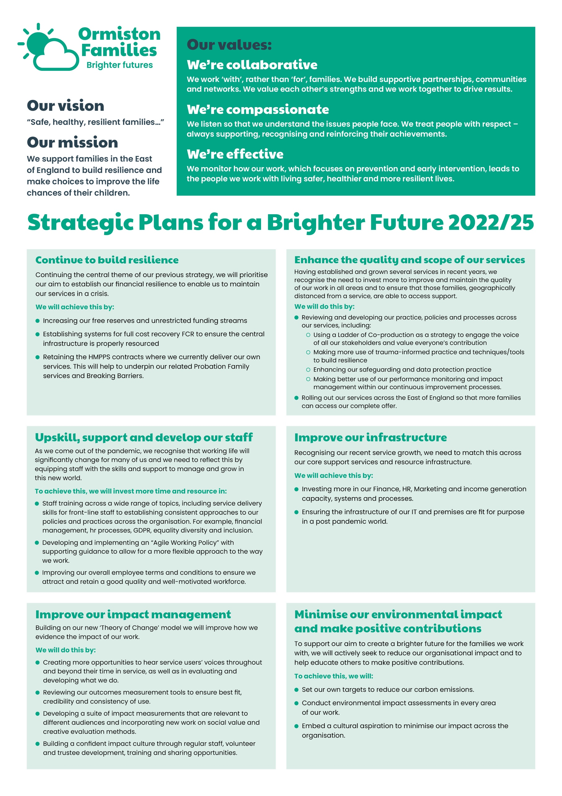
A message from our CEO, Allan Myatt

Dear Applicant,

Thank you for your interest in the post of Practitioner in our YouCanBe Norwich Service.

Over the last three years, the strategic plans we set in 2019 have successfully guided us through a particularly challenging period around the world. Within this time, we have strengthened our infrastructure, said goodbye to some services and welcomed and substantially grown others. We have adopted a new brand identity, giving us a much fresher and more optimistic outlook. We have also invested in our most important asset, our staff, and begun to apply our values across every area of our work. In short, we are now a safer, healthier, and more resilient organisation which has enabled more children, young people and families to feel safer, healthier and more resilient too.

In June last year, we began the process of looking forward to set out a plan for the next three years. We looked at what had been working well and what more needs to be done to improve our quality and reach within the East of England. Our strategic plan for 2022 – 25 has now been approved by our Board of Trustees and we see the recruitment of this post as critical in helping us achieve our objectives.

I wish you the best of luck with your application.

Best regards,

Allan Myatt

Who Are Ormiston Families?

Ormiston Families is one of the leading charities working with children, young people and families in the East of England. We take early and preventative action to support families to be safe, healthy and resilient. All our services help people to build stronger networks, learn from experience and feel in control of their own wellbeing. We can only achieve this with the people who choose to work for us.

About Our YouCanBe Service
YouCanBe is an innovative early intervention service for vulnerable young girls and women who are at risk of pregnancy and subsequent removal.

YouCanBe service users have complex needs and behaviours. The risk factors that may make someone eligible for support from YouCanBe include being care-experience, drug or alcohol misuse, poor mental health, mild learning difficulties, domestic abuse, harmful sexual behaviour, and unhealthy relationships.

YouCanBe provides intensive and goal-oriented support to young women with highly complex needs to improve their ability to think critically, choose healthy relationships, increase their self-esteem, and improve their sexual and reproductive health. Support is one-to-one, long-term and goal based.

YouCanBe is currently available in Ipswich, Lowestoft, Great Yarmouth, and Norwich.

About the role

YouCanBe provides intensive, collaborative, and goal-oriented support designed to address the complex needs of vulnerable young girls and women, and occasionally adults, to improve their ability to think critically, choose healthy relationships, increase their self-esteem, and improve their sexual and reproductive health.

As a Practitioner, you will do this by taking a relational approach that centres around the needs of each young person.

You will work with a high level of independence and self-direction, managing the subtleties of professional boundaries. You will take a flexible approach, where work with different young people can go in a range of directions and last for varying lengths of time.

By joining the service, you will be at the forefront of the exciting expansion of YouCanBe into Norfolk.

About you

It is essential that you have at least 3 years’ experience of working intensively with young people, especially girls and women, with highly complex needs and collaborating on complex safeguarding cases. You must have a good understanding of how poor self-esteem impacts on sexual and reproductive health and relationship choices. You should be confident lone working for extended periods of time and independently making decisions around support for service users. It is essential that you are able to manage your own caseload, completing all case recording paperwork and impact measurement tools. It is also essential that you have your own vehicle and are able to travel within the area.

.

Safer Recruitment

Application Process / Post Requirement
You must demonstrate that you meet the competencies; experience, knowledge, skills, and qualifications, that are required for this role (see Job Description below).
You must complete and submit an online application form (via the ‘Work with Us’ section of our website) detailing in the personal statement section, how you meet the criteria.

Rights to Work in the UK (RTW) (in person or remote)
The Recruiting Manager will need to see the original documents providing proof of your right to work in the UK.
- UK Passport / Full UK Birth Certificate / Drivers Licence / Utilities Bill
(proof of address)
- EUSS Permanent Status or Pre-Status Share Code
- Current EU/EAA/Swiss Citizen Passport
- EU/EAA/Swiss Citizen Visa
- Home Office Certificate
- If the interview is held in person, we will verify hard copy documents which you will need to bring with you to the interview.
- If the interview is held remotely, you will need to email copies of your RTW documents to the Recruiting Manager before the interview. At the remote interview [Teams, Skype, Zoom] you will need to have the original hard copy documents available so the relevant checks can be undertaken.

Safeguarding and DBS Requirements for Your Role
Ormiston Families is committed to safeguarding and promoting the welfare of children, young people and adults at risk and expects all staff and volunteers to share this commitment. DBS checks or police vetting will be required for relevant posts.

Disclosure and Barring Service (DBS) Checks:
- As this position meets the definition of regulated activity under the Protection of Freedom Act 2012, appointments to this post will be subject to an enhanced DBS check with barred list check.
- Employment can commence once the check has been satisfactorily completed.
- If you have a conviction on your DBS check, an assessment of the relevance and impact of the conviction in relation to the post will be done to determine if the job offer can be confirmed.
- It is a serious criminal offence to knowingly apply for posts when you have been barred from working with children/young people and/or vulnerable adults.
- Additional questions for roles working with children, young people, or vulnerable adults to be explored at interview.
- As this post involves working either with children and young people or vulnerable adults Warner or Safer Care motivational type questions may be asked during the interview process.
- These questions are asked to establish your suitability to work with vulnerable groups by understanding your attitude, behaviour, and responses to situations.
- The questions will relate to your inspiration for working with vulnerable groups, your ability to build relationships and your resilience when working with such groups and may also explore your attitude to the use of authority.
- If you feel you would find these questions about yourself difficult to respond to then you may wish to reflect upon your suitability for the post.

Disclosure
- Ormiston Families encourages all candidates called for interview to provide details of their criminal record at an early stage in the application process.
  - This information can be sent under separate, confidential cover to the Human Resources Team hr@ormistonfamilies.org.uk
  - Ormiston Families guarantees that this information will only be seen by those who need to see it as part of the recruitment process.
- Unless the nature of the position allows Ormiston Families to ask questions about your entire criminal record only questions about "unspent" convictions as defined in the Rehabilitation of Offenders Act 1974 will be asked.
- Ormiston Families will ensure that every subject of a DBS Disclosure is aware of the existence of the DBS Code of Practice and make a copy available on request.
- Ormiston Families undertakes to discuss any matter revealed in a Disclosure with the person seeking the position before withdrawing a conditional offer of employment.
- Having a criminal record will not necessarily bar you from working with Ormiston Families. This will depend on the nature of the position and the circumstances and background of the offences.

Qualification
- The Recruiting Manager will need to see the original copies of your qualification either in person or via video conference.
- If the interview is held in person, we will verify hard copy documents which you will need to bring with you to the interview.
- If the interview is held via video conference, you will need to email copies of your qualification to the Recruiting Manager before the interview. At the interview, you will need to have the original hard copy documents available so the relevant checks can be undertaken.
- If short-listed and you are required to hold a particular qualification for a post it is your responsibility to provide the relevant certification, to prove you are suitably qualified.
- Failure to produce documentary evidence of qualifications or undertake required courses/training may result in the termination of your employment.
- If a post requires you to take training or additional qualifications then, by accepting this post, you are agreeing to do the training or take the qualifications.

References
- If appointed, we will ask you for referee details which cover your past 3 years of employment, one of which must be your current/most recent employer.

Health Check
- If appointed and to ensure the post does not have a detrimental effect on your health or your health on your work, you will have to complete a health enquiry form, and may be required to have a medical via Occupational Health.
- This is to confirm that you are able to satisfactorily carry out the post without any impact on your health (taking account of any reasonable adjustments required).
- It will be separated from your application form and will not be seen by anyone involved in recruitment to this job.

GDPR / Data Protection:
- Ormiston Families is required by law to comply with the UK GDPR / Data Protection Act 2018.
- Employees have an important role to play in ensuring that personal information is processed lawfully and fairly.
- Personal information is information relating to a living individual who can be identified.
- It is each individual employee’s responsibility to handle all personal information properly no matter how it is collected, recorded and used, whether on paper, in a computer, or on other material.
- Personal information must not be disclosed to others unless authorised to do so.
- All personal /sensitive information will be sent to you via Egress encryption service or password protected.

Equal Opportunities:
- Ormiston Families is an equal opportunities employer.
- We value diversity and welcome applications from all sections of the community.
- We ask you to complete a monitoring form to help us monitor the diversity of applicants. It will be separated from your application form and will not be seen by anyone involved in recruitment to this job.
- The gender identity, disability, marital status, ethnic origin, age, pregnancy status, religion or belief, or sexual orientation of an applicant or employee does not affect the employment opportunities made available, except as permitted by legislation.
- In addition, applicants declaring a disability who meet the minimum (essential) criteria for a vacancy will be invited for interview.
- Ormiston Families seeks to ensure that all employees are selected, trained, and promoted on the basis of ability, the requirements of the post and other similar and objective criteria.

We will also consider applications for 28 or 35 hours per week, however please make contact with the Regional Manager Christian Iszchak via Christian.iszchak@ormistonfamilies.org.uk or 07719 973 027 to discuss this before making an application.

Any queries, please email: christian.iszchak@ormistonfamilies.org.uk
or call: 07719 973 027

Ormiston Families reserves the right to close the vacancy early if we have received sufficient applications ahead of the closing date.

Information about working
for Ormiston Families

Job Title: Practitioner – YouCanBe Norwich
Duration:
The post advertised is a part-time one-year, fixed term, with the likelihood of extension; 21 hours per week with flexible or agile working.

We will also consider applications for 28 or 35 hours per week, however please make contact with the Regional Manager Christian Iszchak via Christian.iszchak@ormistonfamilies.org.uk or 07719 973 027 to discuss this before making an application.

Hours of Work and Working Arrangements:
- The normal working week is 35 hours, Monday to Friday and covers 52 weeks per year.
- You will be required to work flexibly to meet the needs of the service which may include evenings and weekends.

Location:
- Your base will be will be 11 Prince of Wales Road, Norwich, Norfolk, NR1 1BD.

Salary:
- The scale for this post is grade 6 point 22, £13,420 per annum, based on 21 hours per week. (FTE salary is £22,367 per annum based on 35 hour week)
- Salary is paid in 12 equal instalments on the 25th of each month directly into your bank account and covers work carried out in the calendar month.

Probationary Period:
- The post is subject to a probationary period of 6 months during which your progress will be monitored in accordance with agreed objectives.
Travelling Requirements for Your Role
- Ormiston Families positively encourages the use of technology to communicate and engage but in this role you will need to travel.
- You must either hold a full and current driving licence and have access to personal transport or meet the mobility requirements of the role through other reasonable and suitable means.
- Any mileage undertaken on behalf of Ormiston Families will be paid in accordance with our Expenses Policy and within Her Majesty’s Revenue and Customs guidelines.
- If you require a reasonable adjustment due to a disability to meet the travel requirements of this role, please speak with the contact detailed below.
- If you use your own vehicle for the purposes of work, you must ensure that your insurance policy covers you for this purpose.

Job Description

Job Title: Practitioner
Service: YouCanBe
Location: Norwich

Job Purpose
To provide intensive, collaborative, and goal-oriented support designed to address the complex needs of vulnerable young people, and occasionally adults, to improve their ability to think critically and choose healthy relationships. YouCanBe uses a relational approach; therefore, the length of time that we engage with young people is subject to flexible timescales. Ultimately, YouCanBe enables young people to make meaningful change and prevents unborn children being placed into care.

Main Duties and Responsibilities
- Develop highly supportive relationships with service users – sometimes for extended periods of time – exercising excellent judgement on the subtlety of professional boundaries and the limits surrounding support.
- Undertake collaborative and sensitive assessments of service user’s needs and strengths in order to agree goals and create an evidence base for focussed work. This includes holding in mind from the outset the support that needs to be scaffolded around them to achieve an effective ending.
- Plan, deliver and evaluate sessions with service users in a collaborative way, through group or individual work, to achieve agreed goals. Sessions can range from focussed educative activities around relationships and sex education to listening and responding empathically and appropriately.
- Take an effective, flexible, and intensive approach to engaging with service users, recognising that their complex and traumatic histories can make service engagement difficult.
- Empower service users to engage with a range of other services and organisations. This includes working intensively and tenaciously with other services to support engagement. Support services include sexual health, sexual abuse, substance misuse, domestic abuse, and mental health.
- Build and maintain a strong network of professionals from a variety of providers, including statutory services, for the purpose of generating referrals and finding additional support for service users.
- Take a tenacious approach to developing relationships with the other professionals working with service users, ensuring communication is clear and consistent. This includes attending meetings and taking the lead in a multi-agency approach.

Generic Responsibilities
- Embed a continuous learning ethos within individual and team practice, including involvement in reflective practice discussions and contributing to service development.
- Keep factual and accurate records in line with Ormiston’s processes and funder requirements, assisting colleagues with data recording and reporting, and inputting into reports as requested.
- Ensure all practice matters relating to child protection or vulnerable adults are dealt with promptly and in line with local and internal safeguarding processes.

Generic Duties
- To undertake any other reasonable duty, which is appropriate to the grade when requested by senior staff.
- To be familiar with and comply with all Ormiston Families policies, procedures, protocols and guidelines.
- To demonstrate an understanding and commitment to the charity’s values.
- You may be required to conduct other tasks based on the business needs.

Personal Specification

Qualifications

Essential | Desirable
NVQ 4 or equivalent in relevant subject, e.g. Health & Social Care, Youth Work, etc
Or
3 years’ relevant CPD, such as trauma-informed practice, relationships and sex education training, motivational interviewing, etc.
Safeguarding Core Programme or equivalent
A full driving license. You must be able to travel independently within the county and have access to your own vehicle. Transporting service users in your vehicle will be necessary

Experience

Essential | Desirable
3 years’ experience in a relevant setting, e.g. social work, family work, mental health, youth work, etc.
3 years’ experience of assessing service userss needs and using the information as the evidence base for support plans. This should include experience of tailoring support for service users at different points in their lives and with varying developmental ages and capacity

Abilities and Knowledge

Essential | Desirable
Working knowledge of good sexual health practices
Working knowledge of how trauma impacts on relationships
Working knowledge of how low self-esteem affects young people
A high level of resilience when working intensively with people with complex needs
The ability to practice self-reflection in a way that models positive behaviour to service users and colleagues
Able to work with people who have experienced, and are currently experiencing, trauma
Adaptable communication skills with service users and professionals, including empathic listening, positive challenge, and the ability to sensitively deal with complex
Able to develop local networks to promote service understanding, generate referrals and identify support to scaffold around service users
Able to manage own workload and work on own initiative, balancing work with service users, administrative tasks, and other duties
The necessary computer literacy skills to record clear, accurate information in a variety of formats
A good understanding of equal opportunities, diversity, health and safety, and data protection

Professional and Personal Development
- All staff must ensure that they are aware of their responsibilities by attending mandatory training and our induction programme.
- All staff will have a formal appraisal with their manager at least every 12 months. Once performance/training objectives have been set, the staff member’s progress will be reviewed on a regular basis so that new objectives can be agreed and set, in order to maintain progress in the service delivery.
- All staff will be expected to take responsibility for their own professional development and will be supported to achieve development opportunities as appropriate.

Health and Safety
- All staff have a responsibility to maintain the health and safety of self and others within the performance of duties in accordance with health and safety policies, and to undertake specific health and safety responsibilities as directed. All staff have a responsibility to adhere to the risk management policies & procedures.
- All staff are required to contribute to the control of risk, and must report immediately any incident, accident or near miss involving service users, carers, staff, contractors or members of the public.

Confidentiality and Information Governance
- All staff may gain or have access to confidential information about the assessment and/or treatment of service users, information affecting the public, private or work related staff information, or charity matters. A breach of confidentiality will have occurred where any such information has been divulged, passed (deliberately or accidentally) or overheard by any unauthorised person or person(s). Breaches of confidentiality can result in disciplinary action, which may involve dismissal.
- All staff must maintain a high standard of quality in corporate and clinical record keeping, ensuring information is always recorded accurately, appropriately and kept up to date. Staff must only access information, whether paper, electronic or in other media which is authorised to them as part of their duties.
- All staff must ensure compliance with the Data Protection Act 2018 and the UK GDPR.
Safeguarding: Adults and Children (Section 11 of the Children Act 2004)
- Every member of staff has a responsibility to be aware of and follow at all times, the relevant national and local policy in relation to safeguarding children and safeguarding adults.
- Safeguarding and DBS requirements for your role:
- Ormiston Families is committed to safeguarding and promoting the welfare of children, young people and adults at risk and expects all staff and volunteers to share this commitment. DBS checks or police vetting will be required for relevant posts.

Senior Managers
- Under Section 11 of the Children Act senior managers have responsibility for ensuring that service developments take into account the promotion of welfare and is informed by the views of children and families; providing training on safeguarding for all staff; recruiting safely; ensuring there is effective inter-agency working and information sharing.

Freedom of Information (FOI)
- All members of staff must be aware of their responsibilities under the Freedom of Information (FOI) Act 2000. The Act gives individuals or organisations the right to request information held by the charity. Staff must manage information they hold in such a way that meets the requirements of the Act. All requests for disclosures under the Act must be passed to the Privacy Officer.

Data Quality
- The Charity recognises the role of reliable information in the delivery & development of its services and in assuring robust clinical and corporate governance. Data quality is central to this and the availability of complete, comprehensive, accurate and timely data is an essential component in the provision of high-quality mental health services. It is therefore the responsibility of all staff to ensure that where appropriate, information is recorded, at all times, in line with the charity’s policy and procedures for data quality.
- This job description seeks to provide an outline of the duties and responsibilities of the post. It is not a definitive document and does not form part of the main statement of terms and conditions. The job description will be reviewed as part of the annual appraisal process and will be used as the basis for setting objectives.

Benefits & Recognition
All benefits are discretionary, and Ormiston Families reserves the right to change or amend benefits at any given time.
Cycle to Work
- Cycle to Work allows you to order a new bike, equipment or both up to the value of £1,000 which you can pay back through your salary to make tax savings.

Annual Leave Entitlement:
- The basic annual leave entitlement is 27 days plus additional leave for employees who have completed 1 year’s service up to a maximum of 30 days
- Part-time employees receive a pro-rata allowance according to the number of hours they work per week.
- Ability to buy and sell up to 5 days’ annual leave within any leave year. (All leave must be taken within the year it is purchased including any agreed leave brought forward from the previous year.)

Group Life Assurance:
- Ormiston Families provides a death in service benefit to all permanent employees.
Occupational Sick Pay Scheme:
- Ormiston Families operates an occupational sick pay scheme in addition to statutory sick pay.

Pension:
- Ormiston Families provides a Group Personal Pension Scheme with up to 9% of gross salary employer contribution for any employee where they match the level of contribution.

Sponsorship:
- Ormiston Families provides the opportunity to apply for sponsorship to employees who have completed their probationary period and been in post for at least 12 months to undertake nationally accredited or chartered certification awarded by professional associations.

Employee Assistance Programme:
- Ormiston Families provides a comprehensive employee assistance programme which offers free and confidential access to telephone and face to face counselling (up to 6 sessions), financial and legal advice and assistance in finding information about a wide range of subjects from childcare to moving to a new house.

The Hive:
- The Hive is a savings platform which can be accessed by employees to make everyday purchases at reduced costs. Employees can save money by purchasing reloadable cards, obtain cashback through online purchases, and make savings in some stores.

The Wellbeing Centre:
- Accessed via The Hive, the Wellbeing Centre provides education, support and tools to help you live a healthier and happier life.
We build supportive partnerships, communities and networks

