UCL Application Guidance
Postgraduate Certificate in Child and Young Persons Psychological Wellbeing Practice

All applicants to the Child and Young Persons Psychological Wellbeing Practice, Pg Cert programme will be required to undertake Postgraduate Certificate level training at University College London alongside a work placement.

Please note that you will need to submit an application to University College London for a place on the programme, in addition to the job application that you make to the relevant service.

On successful entry to the programme, all trainees will be required to attend teaching for up to three days per week. The programme is delivered in conjunction with the Anna Freud Centre where most of the teaching will be based at Rodney Street. In light of the Covid-19 situation, teaching is likely to be delivered in a blended format (mix of online and face to face teaching). Students will be taught using a combination of lecture style workshops and small group seminars. Assessment on the programme will comprise of a combination of written, oral and video assessments. On successful completion of the programme, students will graduate with a Postgraduate Certificate in Child and Young Persons Psychological Wellbeing Practice.

Entrance Criteria

Applications to the programme will be reviewed against the following criteria:

- A minimum of a second-class Bachelor's degree from a UK university or an overseas qualification of an equivalent standard in a relevant subject (e.g. psychology)
- Motivation to undertake and complete the programme
- If your education has not been conducted in the English language, you will be expected to demonstrate evidence of an adequate level of English proficiency.
Further information can be found on our English language requirements page at http://www.ucl.ac.uk/prospective-students/graduate/life/international/english-requirements. The English language requirement for this programme is: Good
Please note that applications will not be considered from applicants who are formally registered (or re-sitting examinations) for another programme of study at UCL or any other Higher Education Institution.

Making an application

Please follow the steps provided below to complete your online application. This application should be submitted in addition to the job application.

Please click on the following link:
http://www.ucl.ac.uk/prospective-students/graduate/apply

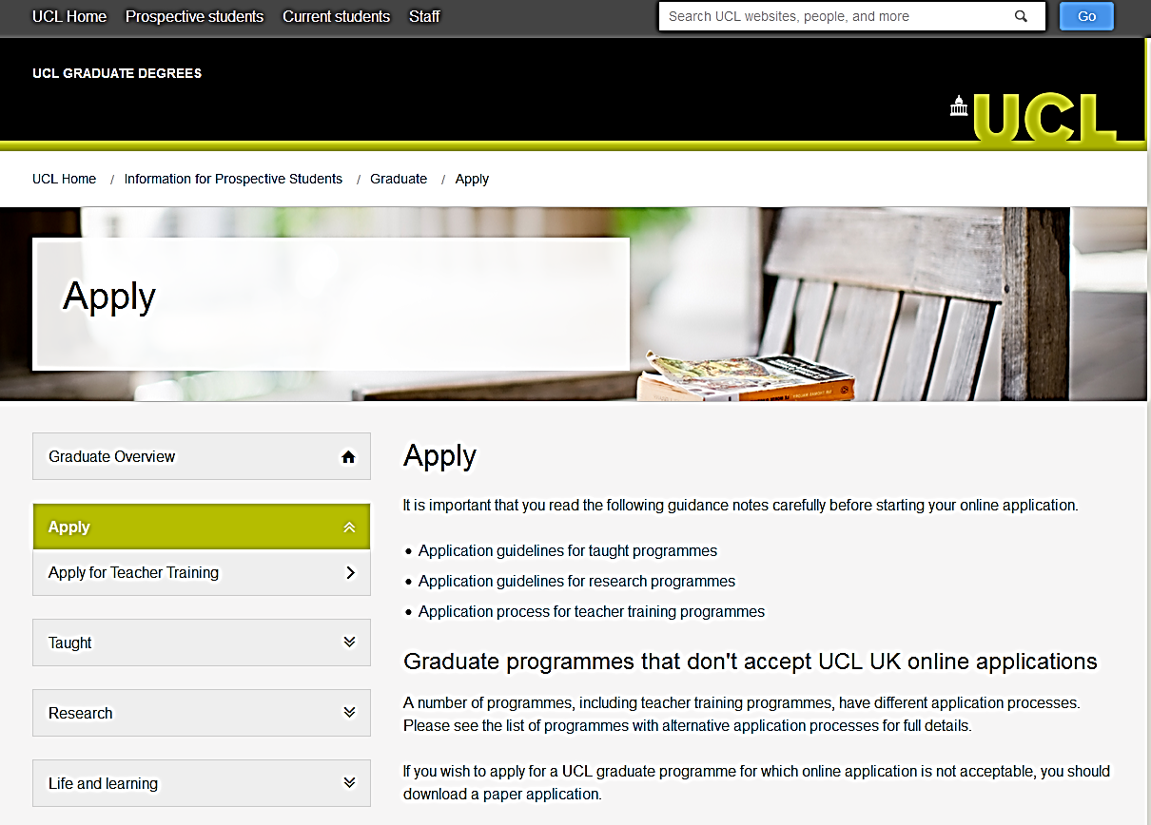
You will get to this page:

Scroll down to the end of the page, and click the blue ‘Accept and Apply’ button:

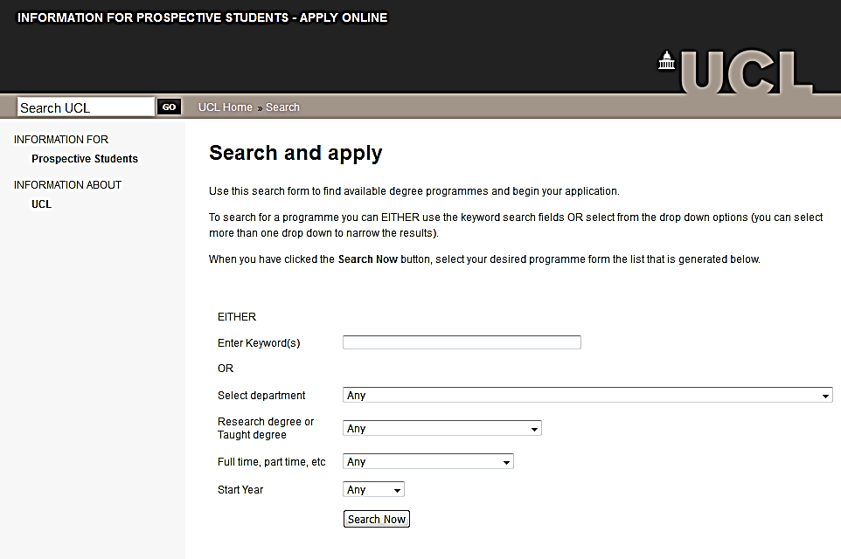
You will get to this page:

In the keywords search, enter ‘Child and Young Persons Psychological Wellbeing Practice’ and click on ‘Search Now’:

You will get several matching programme options. Click on ‘Apply Now’ for the PG Cert Child and Young Persons Psychological Wellbeing Practice (Mixed Mode) TCPPSYSCYM01

You will get to this page:

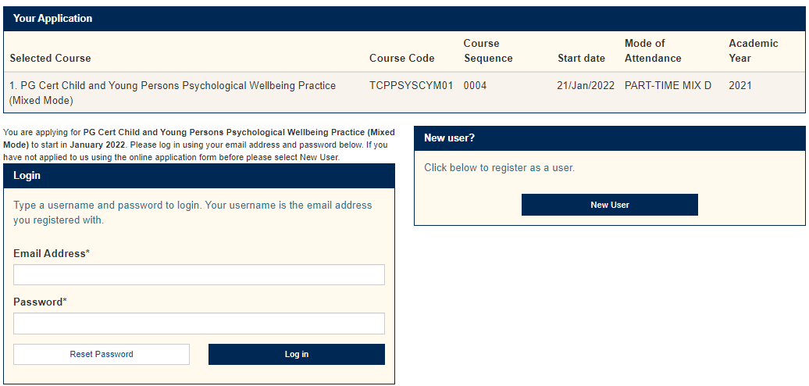

If you have not used the system previously, Click on ‘New User’:
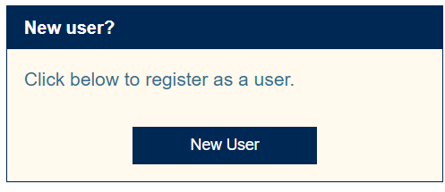

You will get to this page:
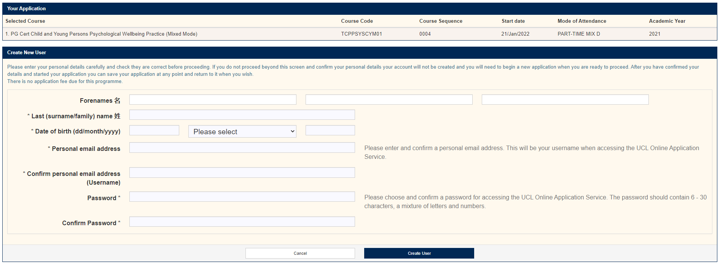

Proceed by filling in your information. You can return to continue your application at any time once you have set up an account.

For more guidance and help, follow the link below:
http://www.ucl.ac.uk/prospective-students/graduate/apply

Personal Statement
As part of your online application, we would like you to write a personal statement of up to 1000 words.
Please include:

- Why would you like to complete this programme?
  - Personal motivation
  - Career relevance
- Describe any relevant experience you have in the field
- How would you cope with the academic demands of the programme?

Interviews
Upon submission of your two applications, your job application will be considered, and you will be informed of whether you have secured an interview with the service. The interview will consist of questions from the service and from the University and the final decision on your application will be made by the employer and the university in collaboration.

Further Queries
If you have further questions, please contact the UCL CYP IAPT office for queries relating to the programme by emailing cwp.admin@annafreud.org

